JOB DESCRIPTION

Job Title: Driving Assessor
Salary: £29,290
Hours: 37.5 (FTE) hours per week
Department: Mobility Services
Location: Carshalton and Winchester
Reports to: Driving Assessor Lead
Staff Management: To provide support, advice and peer review for other ADIS

JOB PURPOSE

The role involves undertaking driving assessments as part of a multi-disciplinary team. In addition, this role involves providing informed advice and recommendations relating to the impact of a client’s medical condition or disability on their driving ability. This will include advice, as part of the team, on current driving ability, possible vehicle adaptations and, in some cases, driver cessation.
The post holder will also deliver a range of specialist vehicle and car adaptation assessments to include vehicle access, passenger transfer and equipment stowage assessments as part of a multi-disciplinary team. The post holder will also provide specialist-driving tuition if required to Mobility Centre clients.

ROLE RESPONSIBILITIES

- To carry out driving assessments for clients with a range of conditions at a range of QEF venues or satellites.
- To deliver driving lessons to clients of QEF Mobility Services using a range of vehicle adaptations.
- To provide advice to other staff and clients regarding driving requirements, licensing and legislation.
- To produce high quality reports in a timely manner including Medico-legal and litigation reports.
- To support the Driving Assessor & ADI Team Lead in service development and working towards standards required by Driving Mobility and our other stakeholders.
- To undertake wheelchair accessible vehicle, passenger transfer, boot hoist assessments in conjunction with a healthcare professional.
- To be responsible for your own CPD and to undertake training as required by Driving Mobility Accreditation.
- To support QEF training and other events as required both internal and external.
- To take a proactive role in ensuring equipment/vehicles fleet are safe and appropriate for service delivery.
- To have a responsibility for the H&S for yourself and clients and to participate in H&S activities within the service.
- To undertake other reasonable activities as required by line manager or centre manager.

BEING PART OF QEF MEANS

- Actively participating in learning, development and feedback opportunities and cycles as required by QEF’s policies and procedures.
- Acting in accordance with relevant legislative and regulatory requirements as may apply from time to time.
- Supporting and encouraging the involvement of volunteers.
- Promoting QEF’s Equal Opportunities policy and avoiding any behaviour that either directly or indirectly discriminates against others on the grounds of any protected characteristic.
- Taking Health and Safety duties seriously to ensure your safety and that of your colleagues and our residents and clients.
- Being an active team player and attending team meetings and briefings to which you are invited.
- QEF is committed to safeguarding and promoting the welfare of children and adults at risk and expects all staff and volunteers to share this commitment. All staff and volunteers must be responsible and accountable for their safeguarding practice and proactive in identifying and reporting safeguarding concerns.
- Being an ambassador of QEF’s Values and Behaviours in your approach to your role and to our staff, clients, and residents.

VALUES AND BEHAVIOURS
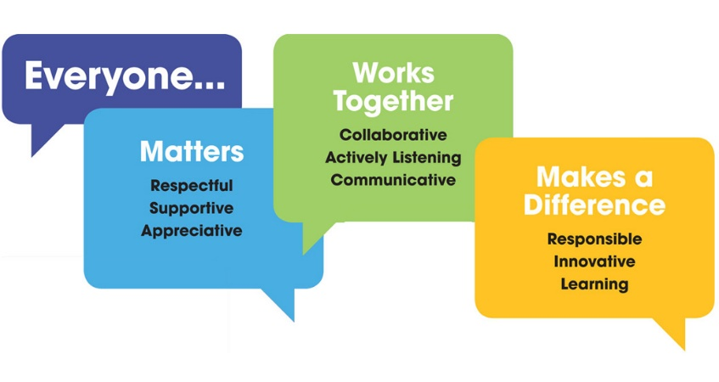

OTHER DUTIES

- You are expected to perform various tasks as necessitated by your changing role within QEF and the charity’s overall business objectives as reasonably requested by your designated manager or the CEO.
- You must read and ensure you understand the current versions of QEF’s policies and procedures and undertake to act in accordance with them at all times.
- You may be required to work at other locations in accordance with the responsibilities and duties of your role.
- The above is not an exhaustive list of duties and may be subject to change.

PERSON SPECIFICATION

Job title | Driving Assessor
Department | Mobility Services
QUALIFICATIONS AND TRAINING |  | ESSENTIAL | DESIRABLE
Fully qualified driving instructor registered with DVSA |  | Y
Educated to GSCE level or similar |  | Y
Teaching qualification |  |  | Y
Completion of Driving Mobility WBIS education programme |  |  | Y
KNOWLEDGE AND SKILLS
Ability to communicate clearly both verbally and in writing |  | Y
Ability to transfer knowledge to both pupils and other staff |  | Y
Working knowledge of a variety of standard vehicle adaptations and controls |  | Y
Working knowledge of complex vehicle adaptations and controls |  | Y
Understanding and awareness of transfer solutions, boot hoists and wheelchairs |  |  | Y
EXPERIENCE
Significant experience of driving tuition |  | Y
Experience of teaching people with physical or learning abilities to drive |  | Y
Experience of training others |  | Y
Experience with working with people with physical or learning disabilities |  | Y
PERSONAL ATTRIBUTES
Demonstrable ability to be an ambassador of QEF’s Values & Behaviours. |  | Y
Excellent interpersonal skills |  | Y
Willingness to work as part of a team |  | Y
Ability to work alone |  | Y
Willingness to learn new skills and acquire knowledge |  | Y

