JOB DESCRIPTION

Job Title | Driving Assessor
Hours | 22.5 hours per week (37.5 hours per week FTE)
Department | Mobility Services
Location | Carshalton
Reports to | Driving Assessment Team Lead
Responsible for | Delivering assessments for driving, vehicle adaptations, and passenger transfer into a vehicle

QEF & ITS FAMILY OF CHARITIES

QEF is a Surrey-based charity committed to providing life-transforming services that enable people with disabilities to increase their independence and achieve their goals in life.

We work with over 10,000 disabled children and adults every year with physical or learning disabilities or acquired brain injuries. Whether it’s gaining new skills to live independently, rehabilitation after a brain injury or stroke, or improving independence through increased mobility and accessible holidays; QEF helps disabled people to fulfil their potential in life.

QEF is structured into two main services - Mobility Services (who operate outreach services across the South of England), Care and Rehabilitation Centre located within our Leatherhead in Surrey campus. These are augmented by QEF Retail Trading (14 retail charity shops) and a family of smaller charities - MERU which provides innovative product solutions for Children and The Grange in Kent a residential care home for adults with a learning disability.

ROLE CONTEXT

Endorsed by the Department for Transport, QEF Mobility Services is one of the UK’s top 2 providers and, complete over 1,700 mobility assessments each year. They also provide advice and training with adaptations and solutions to ensure maximum mobility.
Driving Assessments objectively measure the capability to drive safely; suitable for those returning to driving, older people at licence renewal or those requiring clarification if there is any concern. We also provide advice and training with adaptations and solutions to ensure maximum mobility.

Passenger assessments provide independent advice on suitable equipment to remove or minimise the risks of manual handling to ensure safe and comfortable transfer of individuals and their equipment into a vehicle.

JOB PURPOSE

- To provide a quality assessment service for people with reduced mobility caused by disability, illness or age.
- To provide high-quality assessments, informed advice and recommendations relating to the impact of a client’s medical condition or disability on their driving ability and applying client centred principles. This will include advice on possible vehicle adaptations and, in some cases, driver cessation.
- To deliver a range of specialist vehicle and car adaptation assessments to include vehicle access, passenger transfer and equipment stowage assessments as part of a multi-disciplinary team.
- To provide specialist-driving tuition if required to Mobility Centre clients.
- To be a proactive member of a multi-disciplinary team respecting their professional guidelines and opinions.
- To work to ensure all client interaction is provided in compliance with QEF policies.

ROLE RESPONSIBILITIES

- To carry out driving assessments for clients with a range of conditions at a range of QEF venues or satellites.
- To deliver driving lessons to clients of QEF Mobility Services using a range of vehicle adaptations.
- To provide advice to other staff and clients regarding driving requirements, licensing and legislation.
- To produce high quality reports in a timely manner including Medico-legal and litigation reports.
- To support the Driving Assessor Team Lead and Senior Driving Assessor in service development and working towards standards required by Driving Mobility and our other stakeholders.
- To undertake wheelchair accessible vehicle, passenger transfer, boot hoist assessments in conjunction with a healthcare professional.
- To be responsible for your own CPD and to undertake training as required by Driving Mobility Accreditation.
- To support QEF training and other events as required both internal and external.
- To take a proactive role in ensuring equipment/vehicles fleet are safe and appropriate for service delivery.
- To have a responsibility for the H&S for yourself and clients and to participate in H&S activities within the service.
- To undertake other reasonable activities as required by line manager or centre manager.

BEING PART OF QEF MEANS

- Actively participating in learning, development and feedback opportunities and cycles as required by QEF’s policies and procedures.
- Acting in accordance with relevant legislative and regulatory requirements as may apply from time to time.
- Supporting and encouraging the involvement of volunteers.
- Promoting QEF’s Equal Opportunities policy and avoiding any behaviour that either directly or indirectly discriminates against others on the grounds of any protected characteristic.
- Taking Health and Safety duties seriously to ensure your safety and that of your colleagues and our residents and clients.
- Being an active team player and attending team meetings and briefings to which you are invited.
- QEF is committed to safeguarding and promoting the welfare of children and adults at risk and expects all staff and volunteers to share this commitment. All staff and volunteers must be responsible and accountable for their safeguarding practice and proactive in identifying and reporting safeguarding concerns.
- Being an ambassador of QEF’s Values and Behaviours in your approach to your role and to our staff, clients, and residents.

VALUES AND BEHAVIOURS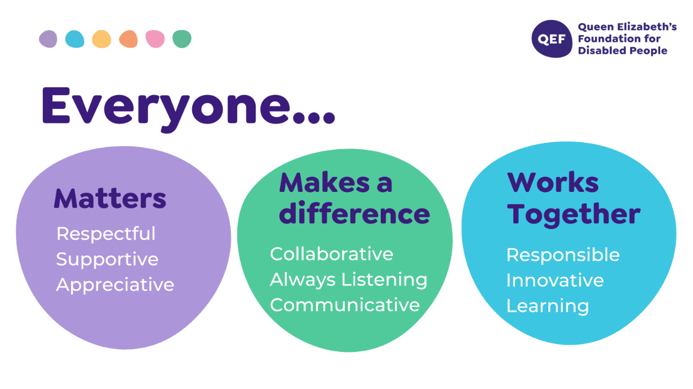

OTHER DUTIES

- You are expected to perform various tasks as necessitated by your changing role within QEF and the charity’s overall business objectives as reasonably requested by your designated manager or the CEO.
- You must read and ensure you understand the current versions of QEF’s policies and procedures and undertake to act in accordance with them at all times.
- You may be required to work at other locations in accordance with the responsibilities and duties of your role.
- The above is not an exhaustive list of duties and may be subject to change.

PERSON SPECIFICATION

Job title | Driving Assessor
QUALIFICATIONS AND TRAINING |  | ESSENTIAL | DESIRABLE
Fully qualified driving instructor registered with DVSA |  | Y
Educated to GSCE level or similar |  | Y
Teaching qualification |  |  | Y
Completion of Driving Mobility WBIS education programme |  |  | Y
KNOWLEDGE AND SKILLS
Ability to communicate clearly both verbally and in writing |  | Y
Ability to transfer knowledge to both pupils and other staff |  | Y
Working knowledge of a variety of standard vehicle adaptations and controls |  | Y
Working knowledge of complex vehicle adaptations and controls |  |  | Y
Understanding and awareness of transfer solutions, boot hoists and wheelchairs |  |  | Y
EXPERIENCE
Significant experience of driving tuition |  | Y
Experience of teaching people with physical or learning abilities to drive |  | Y
Experience of training others |  | Y
Experience of working with people with physical or learning disabilities |  | Y
PERSONAL ATTRIBUTES
Demonstrable ability to be an ambassador of QEF’s Values & Behaviours. |  | Y
Excellent interpersonal skills |  | Y
Willingness to work as part of a team |  | Y
Ability to work alone |  | Y
Willingness to learn new skills and acquire knowledge |  | Y
Commitment to continuous professional development |  | Y
To be empathetic and passionate in working with clients and families, with complex physical, cognitive and psychosocial needs |  | Y

