JOB DESCRIPTION

Job Title | Clinical Psychologist/Counselling Psychologist Band 7
Hours | 37.5 hours per week (37.5 hours per week FTE)
Department | Therapies
Level | Band 7
Reports to | Clinical Psychologist Band 8a

JOB PURPOSE

To provide a direct psychological service to clients, carrying out assessments of their needs and abilities and using this information to formulate and monitor appropriate programmes and strategies. To support staff engaged in the cognitive, physical communication, functional, social and emotional rehabilitation of adults with acquired brain injury.

ROLE RESPONSIBILITIES

- To provide a direct psychological service to clients, conducting and interpreting a wide range of assessment procedures.
- To provide therapeutic support to clients through group work and individual sessions.
- To prepare detailed professional reports on client assessment and progress and make recommendations for future provision.
- To direct and supervise the clinical work of the junior staff and psychology students in the psychology department.
- To provide staff training/awareness/advice to colleagues on the cognitive, emotional and behavioural implications of acquired brain injury and to devise, implement and monitor strategies to facilitate learning and management of the behaviour of clients.
- To initiate and engage in formal research projects, publishing as appropriate.
- To conduct analysis of psychology and clinical outcomes as appropriate.
- To support the Psychology team and members of the multi-disciplinary team, as required.
- To advise Head of Clinical Services on the suitability of prospective clients.
- To represent the Service at required meeting both clinical and non-clinical and giving presentations / sharing in training
- To keep abreast of developments in the field of brain injury rehabilitation.
- To support the team and families in planning discharges taking into account psychological and cognitive needs.
- To assess and manage mental capacity and risk issues as appropriate in collaboration with the Lead Psychologist and wider MDT.
- To support the team in managing the emotional impact of looking after clients with significant cognitive, communication and/or physical difficulties.

BEING PART OF QEF MEANS

- Actively participating in learning, development and feedback opportunities and cycles as required by QEF’s policies and procedures.
- Acting in accordance with relevant legislative and regulatory requirements as may apply from time to time.
- Supporting and encouraging the involvement of volunteers.
- Promoting QEF’s Equal Opportunities policy and avoiding any behaviour that either directly or indirectly discriminates against others on the grounds of any protected characteristic.
- Taking Health and Safety duties seriously to ensure your safety and that of your colleagues and our residents and clients.
- Being an active team player and attending team meetings and briefings to which you are invited.
- Being an ambassador of QEF’s Values and Behaviours in your approach to your role and to our staff, clients, and residents.

VALUES AND BEHAVIOURS
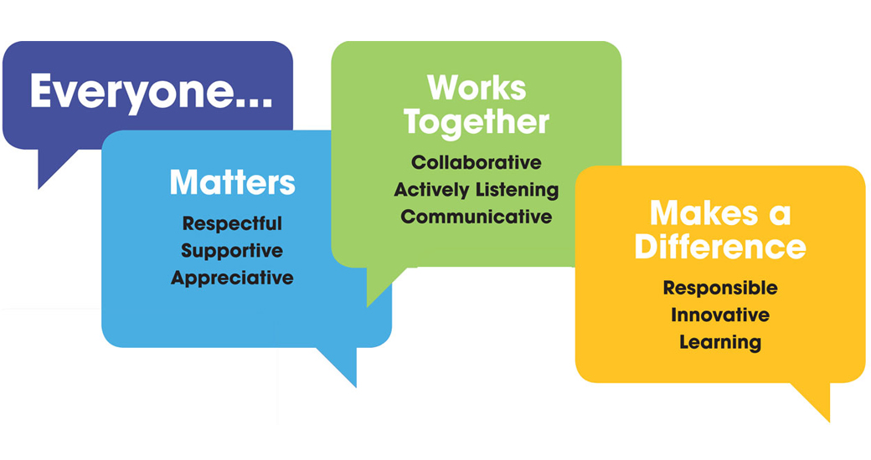
OTHER DUTIES

- You are expected to perform various tasks as necessitated by your changing role within QEF and the charity’s overall business objectives as reasonably requested by your designated manager or the CEO.
- You must read and ensure you understand the current versions of QEF’s policies and procedures and undertake to act in accordance with them at all times.
- You may be required to work at other locations in accordance with the responsibilities and duties of your role.
- The above is not an exhaustive list of duties and may be subject to change.

PERSON SPECIFICATION
Job title | Clinical Psychologist/Counselling Psychologist Band 7
QUALIFICATIONS AND TRAINING |  | ESSENTIAL | DESIREABLE
Doctoral level training in Clinical or Counselling Psychology |  | Y
Up to date HCPC registration/ or for newly qualified clinical psychologists, due for registration once course is complete |  | Y
Professional qualifications and experience in any of the following: Neuropsychology, counselling, psychotherapy, or behaviour management |  |  | Y
KNOWLEDGE AND SKILLS
Excellent written and verbal communication skills |  | Y
Competent in Microsoft Word, Excel and Outlook |  | Y
Good decision making and problem solving skills |  | Y
Able to manage workload independently and work as part of a multi-disciplinary team |  | Y
The ability to use and interpret specialist psychological and neuro-psychological assessment materials |  | Y
Skills in providing consultation to other professional and nonprofessional groups |  | Y
High level knowledge of the theory and practice of at least two specialised psychological therapies |  | Y
Knowledge of current theoretical models and skills in working with people whose behaviour challenges |  | Y
Doctoral level knowledge of research methodology, research design and complex, multivariate data analysis as practised within the clinical fields of psychology |  | Y
Ability to contain, explore and formulate an understanding of high levels of distress both directly with patients and indirectly through consultation with other staff |  | Y
Evidence of continuing professional development as recommended by the BPS |  | Y
Knowledge of the theory and practice of specialised psychological therapies with individuals with acquired brain injury |  |  | Y
Knowledge of legislation in relation to the client group |  |  | Y
Able to reflect on how one’s own issues of difference and diversity influence decision making in clinical practice |  |  | Y
Knowledge of models of cognitive rehabilitation |  |  | Y
Knowledge of theories within health psychology and their application to a neuropsychological setting |  |  | Y
EXPERIENCE
Experience working with people with cognitive impairments |  | Y
Experienced in the use of neuropsychological assessment to inform care planning |  | Y
Experience working with clients who people whose behaviour challenges |  | Y
Experience working with people who have an acquired brain injury / in a neuro-rehab setting or community-based neuro setting |  |  | Y
Experience of assessing and supporting mental capacity
Experience working with staff teams in a residential setting |  |  | Y
Experience working with families |  |  | Y
Experience facilitating psycho-education or psychological therapy groups |  |  | Y
Experience delivering mindfulness-based interventions |  |  | Y
Experience supervising assistant psychologists |  |  | Y
PERSONAL ATTRIBUTES
Ability to teach and train others, using a variety of complex multi-media materials suitable for presentations within public, professional and academic settings |  | Y
Experience of working within a multicultural framework |  | Y
Ability to identify and employ mechanisms of clinical governance as appropriate, to support and maintain clinical practice in the face of regular exposure to highly emotive material and challenging behaviour |  | Y
Ability to work effectively within a multidisciplinary service setting |  | Y
Able to be flexible with working schedules, for instance working occasional evening or early mornings to accommodate families and to support staff working shift patterns |  |  | Y

