|  |  |
| --- | --- |
| **JOB DESCRIPTION** | |
| **Job Title:** Approved Driving Instructor (ADI)  **Salary:**  **£24,521**  **Hours:** **37.5 (FTE) hours per week**  **Department:** Mobility Services  **Location:** **Carshalton**  **Reports to:** Driving Assessor Lead |  |

|  |
| --- |
| **QEF & ITS FAMILY OF CHARITIES** _ |

QEF is a Surrey based charity committed to providing life-transforming services that enable people with disabilities to increase their independence and achieve their goals in life.

We work with over 5,000 disabled children and adults every year with physical or learning disabilities or acquired brain injuries. Whether it’s gaining new skills to live independently, rehabilitation after a brain injury or stroke, or improving independence through increased mobility and accessible holidays; QEF helps disabled people to fulfil their potential in life.

QEF has two main services - Neuro Rehabilitation Services located at the Care and Rehabilitation Centre, Leatherhead and Mobility Services at Carshalton. These are augmented by QEF Retail Trading and MERU which provides innovative product solutions for children.

|  |
| --- |
| **ROLE CONTEXT**  _ |

Endorsed by the Department for Transport, QEF Mobility Services is one of the UK’s top 4 providers completing over 1,600 mobility assessments each year designed to improve independent mobility for disabled people and the elderly. ADIs work alongside a multi-disciplinary team of clinicians, driving assessors and administrators to deliver advice, support and an information service as well as practical assessments and driving tuition.

Our range of assessments include manual and powered wheelchairs and scooters and transfer & seating assessments for air travel. In addition to delivering assessments at our main site in Carshalton we also provide clinics at other venues across Surrey, Sussex, Hampshire and London.

QEF’s support services are based at Leatherhead Court. These comprise Accounting and Finance, Facilities, Human Resources, IT and Marketing. They work together to focus on making QEF and its family of charities work as efficiently and smoothly as possible given its multi-site structure.

|  |
| --- |
| **JOB PURPOSE** |

The role involves undertaking driving tuition for people with disabilities, medical conditions or learning difficulties that have received an assessment of their driving ability. The post holder will deliver tuition in a range of specialist vehicles with adaptations as well as non-adapted automatic and manual cars. In addition, you will also provide tuition to students that need additional support to reach the standards required to pass the theory test.

You will help our students learn the skills necessary to become safe and responsible drivers. This role will include giving advice, as part of a multi-disciplinary team, on current driving ability, vehicle adaptations and, in some cases, driver cessation.

|  |
| --- |
| **ROLE RESPONSIBILITIES** |

* Provide driving tuition to learner drivers and experienced drivers with a range of conditions.
* Deliver driving tuition using a range of vehicle adaptations.
* Provide theory tuition to learner drivers
* Provide advice to other staff and clients regarding driving requirements, licensing, and legislation.
* Maintain accurate records of training delivered to students.
* To be responsible for your own CPD and to undertake training as required by Driving Mobility Accreditation.
* To take a proactive role in ensuring equipment/vehicles fleet are safe and appropriate for service delivery.
* To support the Driving Assessor & ADI Team Lead in service development and working towards standards required by Driving Mobility and our other stakeholders.
* Complete risk assessment of driving related activities
* Maintain confidentiality and data security to the relevant standards.
* To undertake wheelchair accessible vehicle, passenger transfer, boot hoist assessments in conjunction with a healthcare professional.
* To support and deliver QEF training and other events as required both internal and external.
* To have a responsibility for the H&S for yourself and clients and to participate in H&S activities within the service.
* To undertake other reasonable activities as required by line manager or centre manager.

|  |
| --- |
| **BEING PART OF QEF MEANS** |

* Actively participating in learning, development and feedback opportunities and cycles as required by QEF’s policies and procedures.
* Acting in accordance with relevant legislative and regulatory requirements as may apply from time to time.
* Supporting and encouraging the involvement of volunteers.
* Promoting QEF’s Equal Opportunities policy and avoiding any behaviour that either directly or indirectly discriminates against others on the grounds of any protected characteristic.
* Taking Health and Safety duties seriously to ensure your safety and that of your colleagues and our residents and clients.
* Being an active team player and attending team meetings and briefings to which you are invited.
* QEF is committed to safeguarding and promoting the welfare of children and adults at risk and expects all staff and volunteers to share this commitment. All staff and volunteers must be responsible and accountable for their safeguarding practice and proactive in identifying and reporting safeguarding concerns.
* Being an ambassador of QEF’s Values and Behaviours in your approach to your role and to our staff, clients, and residents.

|  |
| --- |
| **VALUES AND BEHAVIOURS** |

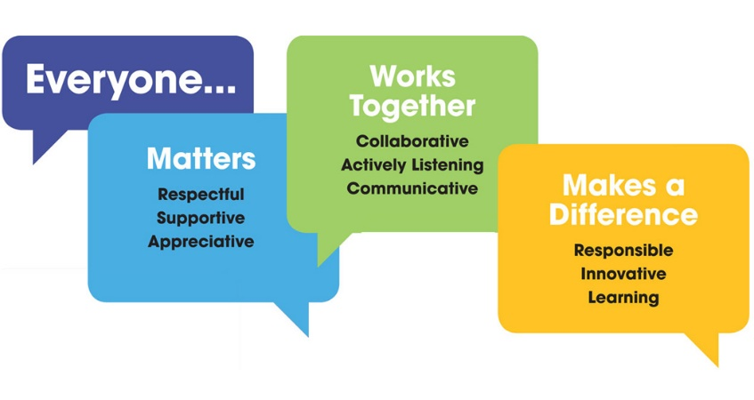

|  |
| --- |
| **OTHER DUTIES** |

* You are expected to perform various tasks as necessitated by your changing role within QEF and the charity’s overall business objectives as reasonably requested by your designated manager or the CEO.
* You must read and ensure you understand the current versions of QEF’s policies and procedures and undertake to act in accordance with them at all times.
* You may be required to work at other locations in accordance with the responsibilities and duties of your role.
* The above is not an exhaustive list of duties and may be subject to change.

|  |  |  |  |
| --- | --- | --- | --- |
| **PERSON SPECIFICATION** | | | |
| **Job title** | **Approved Driving Instructor (ADI)** | | |
| **Department** | **Mobility Services** | | |
|  | | | |
| **QUALIFICATIONS AND TRAINING** | | **ESSENTIAL** | **DESIRABLE** |
| Fully qualified driving instructor registered with DVSA | | Y |  |
| Educated to GSCE level or similar | |  | Y |
| Teaching qualification | |  | Y |
|  | |  |  |
| **KNOWLEDGE AND SKILLS** | |  |  |
| Ability to communicate clearly both verbally and in writing | | Y |  |
| Ability to transfer knowledge to both pupils and other staff | | Y |  |
| Working knowledge of a variety of standard vehicle adaptations and controls | |  | Y |
| Working knowledge of complex vehicle adaptations and controls | |  | Y |
| Understanding and awareness of transfer solutions, boot hoists and wheelchairs | |  | Y |
|  | |  |  |
| **EXPERIENCE** | |  |  |
| Significant experience of driving tuition | | Y |  |
| Experience of training others | | Y |  |
| Experience with working with people with physical or learning disabilities | |  | Y |
| Experience of teaching people with physical or learning abilities to drive | |  | Y |
|  | |  |  |
| **PERSONAL ATTRIBUTES** | |  |  |
| Demonstrable ability to be an ambassador of QEF’s Values & Behaviours. | | Y |  |
| Excellent interpersonal skills | | Y |  |
| Willingness to work as part of a team | | Y |  |
| Ability to work alone | | Y |  |
| Willingness to learn new skills and acquire knowledge | | Y |  |
|  | |  |  |