JOB DESCRIPTION

Job Title: | Occupational Therapist Band 6
Department: | Therapies
Location: | Care and Rehabilitation Centre, Leatherhead
Reports to: | Lead Occupational Therapist

QEF & ITS FAMILY OF CHARITIES
QEF is a Surrey based charity committed to providing life-transforming services that enable people with disabilities to increase their independence and achieve their goals in life.

We work with over 5,000 disabled children and adults every year with physical or learning disabilities or acquired brain injuries. Whether it’s gaining new skills to live independently, rehabilitation after a brain injury or stroke, or improving independence through increased mobility and accessible holidays; QEF helps disabled people to fulfil their potential in life.

QEF is structured into three main services - Independent Living Services, Mobility Services and Care andRehabilitation Services. These are augmented by QEF Retail Trading and a family of smaller charities - MERU which provides innovative product solutions; Sutton Shopmobility and VASD which offer access to and loans of mobility equipment.

ROLE CONTEXT
At QEF Care and Rehabilitation Centre (CRC) we offer neurorehabilitation to clients after a stroke or other acquired brain injury. Our specialist multi-disciplinary team provides residential or outpatient therapies to those with physical, cognitive and/or communication disabilities, which may also include mild to moderate behavioral problems.

We have a diverse range of one-to-one support programmes, tailored to help improve social and functional abilities as well as support for that important move home.

Growing demand for our services, combined with our passion for delivering the highest standards of care and treatment, inspired the move to our new, state-of-the-art Care and Rehabilitation Centre in July 2020. The Centre, especially designed for us, provides a fantastic hub of expertise and technology for people with a wide range of disabilities. It is located next to our head office, Leatherhead Court, in Leatherhead, Surrey.

JOB PURPOSE

To be responsible for the occupational therapy assessment and treatment of clients with acquired brain injury, stroke, incomplete spinal injury and other neurological conditions under the supervision of the senior Occupational Therapists.
To work as a member of the multi-disciplinary team ensuring continuity and consistency regarding clients’ physical and cognitive management.

ROLE RESPONSIBILITIES

- To provide Occupational Therapy assessment and treatment plans which are aligned to the aspirations of the client in maximising functional independence.
- Carry out access and home visit assessment and implement appropriate aids and equipment to maximise functional independence.
- To act as a key worker for clients at CRC. To support their rehabilitation, stay and discharge plan.
- To hold responsibility for own caseload and be responsible for a defined area of the service, working without direct supervision.
- To work as a member of the multi-disciplinary neuro-rehabilitation team, contributing to the planning, development and delivery of an effective and efficient service.
- Ongoing evaluation of treatment regimes in conjunction with the senior therapist.
- Setting of clients’ short- and long-term goals.
- Leading and assisting in splinting as appropriate.
- Integrating and monitoring treatment programmes in the clients’ environment whether carried out by therapy support worker, care and support worker staff.
- Integrating strategies agreed on by the multi-disciplinary team into treatment management.
- Participating in the assessment of wheelchair seating requirements for clients in conjunction with the Physiotherapy department if required.
- Keeping abreast of developments within the profession.
- Supervising the band 5 occupational therapists, students and therapy support workers as required in conjunction with the senior OTs.
- Advising and assisting other session staff on the correct working environment to enable clients to maximise their physical abilities, in conjunction with the senior therapists.
- Contributing to clients’ reports for reviews and case conferences.
- Ensuring that all equipment used is in good order and ensuring the safety of clients and staff at all times in accordance with the Health & Safety at Work Act.
- Providing information, based on professional judgements and experience to clients, families, carers and other involved agencies with implications for future provision.
- Maintaining client records and providing written assessments as required.

BEING PART OF QEF MEANS
- Actively participating in learning, development and feedback opportunities and cycles as required by QEF’s policies and procedures.
- Acting in accordance with relevant legislative and regulatory requirements as may apply from time to time.
- Supporting and encouraging the involvement of volunteers.
- Promoting QEF’s Equal Opportunities policy and avoiding any behaviour that either directly or indirectly discriminates against others on the grounds of any protected characteristic.
- Taking Health and Safety duties seriously to ensure your safety and that of your colleagues and our residents and clients.
- Being an active team player and attending team meetings and briefings to which you are invited.
- QEF is committed to safeguarding and promoting the welfare of children and adults at risk and expects all staff and volunteers to share this commitment. All staff and volunteers must be responsible and accountable for their safeguarding practice and proactive in identifying and reporting safeguarding concerns.
- Being an ambassador of QEF’s Values and Behaviours in your approach to your role and to our staff, clients, and residents.

VALUES AND BEHAVIOURS
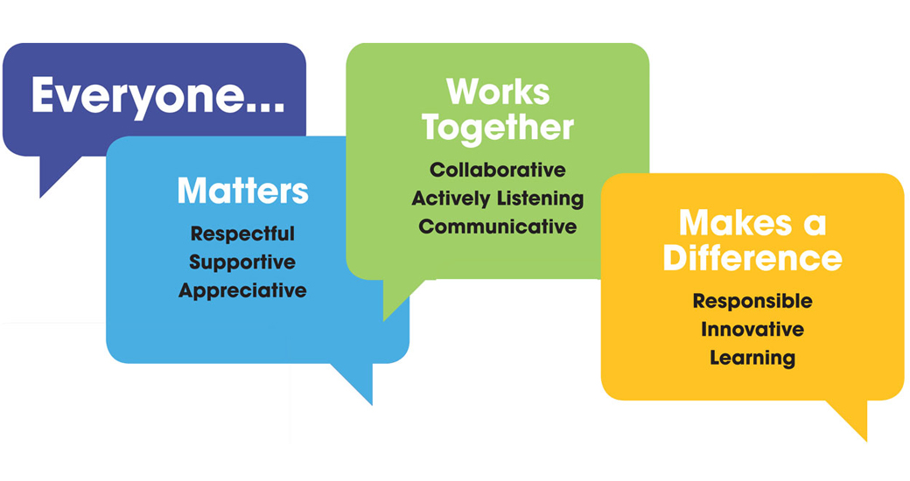

OTHER DUTIES
- You are expected to perform various tasks as necessitated by your changing role within QEF and the charity’s overall business objectives as reasonably requested by your designated manager or the CEO.
- You must read and ensure you understand the current versions of QEF’s policies and procedures and undertake to act in accordance with them at all times.
- You may be required to work at other locations in accordance with the responsibilities and duties of your role.
- The above is not an exhaustive list of duties and may be subject to change.

PERSON SPECIFICATION

Job title: | Occupational Therapist Band 6
Department: | Therapies

KEY CRITERIA | Essential | Desirable
QUALIFICATIONS AND TRAINING
Diploma or Degree in Occupational Therapy | √
Membership of Health Professionals council | √
Evidence of relevant post graduate courses/ continual professional development | √
Membership of BAOT/COT | √
Driver with full driving licence |  | √
Masters module/ qualification |  | √
EXPERIENCE
Post qualification experience of working with physical disability and neurological rehabilitation | √
Experience in working with complex physical conditions | √
Experience of assessing for and ordering/prescribing/fitting  equipment and adaptations |  | √
Experience in administering standardised assessments and clinical reasoning in choosing appropriate assessments including home visits | √
Experience with manual handing | √
Experience in complex manual handling procedures |  | √
Experience in composing risk assessments |  | √
Confident with the use of assistive equipment |  | √
Experience of working in a multidisciplinary team | √
Experience in developing standards and application of national guidelines to clinical practice |  | √
KNOWLEDGE AND SKILLS
Excellent written and verbal communication skills including use of Microsoft Word, PowerPoint, Excel and Outlook | √
Can use own initiative to prioritise caseload and use clinical reasoning to make sound decisions and problem solve | √
Knowledge and skills using different models or frameworks |  | √
Knowledge of neurological national clinical guidelines |  | √
Knowledge of infection control |  | √
Knowledge of clinical governance | √
Have an empathetic approach with the ability to remain objective | √
PERSONAL ATTRIBUTES
Ability to demonstrate efficient, effective self-management including use of time, organisation, planning and problem solving, and managing stress of self and clients | √
Ability to use own initiative but ask for assistance where appropriate | √
Ability to work flexibly and proactively to meet the needs of a varied clinical caseload | √
Able to use self-reflection to improve clinical skills | √
To respond effectively to constructive feedback | √
Commitment to continuous professional development | √
To be empathetic and passionate in working with clients with complex physical, cognitive and psychosocial needs and their families | √

