JOB DESCRIPTION

Job Title | Occupational Therapist
Hours | 37.5 hours per week (37.5 hours per week FTE)
Department | Therapies
Location | Mobility Services, Carshalton
Level | Band 6
Reports to | Senior OT at Mobility Services, Carshalton
Responsible for | Delivering assessments for wheelchairs and scooters, passenger transfer into a vehicle, vehicle adaptations and driving

QEF & ITS FAMILY OF CHARITIES

QEF is a Surrey based charity committed to providing life-transforming services that enable people with disabilities to increase their independence and achieve their goals in life.

We work with over 10,000 disabled children and adults every year with physical or learning disabilities or acquired brain injuries. Whether it’s gaining new skills to live independently, rehabilitation after a brain injury or stroke, or improving independence through increased mobility and accessible holidays; QEF helps disabled people to fulfil their potential in life.

QEF is structured into two main services - Mobility Services (who operate outreach services across the South East of England), Care and Rehabilitation Center located within our Leatherhead in Surrey campus. These are augmented by QEF Retail Trading (15 retail charity shops) and a family of smaller charities - MERU which provides innovative product solutions for Children and The Grange in Kent a residential care home for adults with a learning disability.

ROLE CONTEXT

Endorsed by the Department for Transport, QEF Mobility Services are one of the UK’s top 3 providers and, complete over 1,600 mobility assessments each year.
Wheelchair and scooter assessments provide independent assessment through trial of a variety of equipment to identify the most suitable for individual’s needs.

Passenger assessments provide independent advice on suitable equipment to remove or minimise the risks of manual handling to ensure safe and comfortable transfer of individuals and their equipment into a vehicle. This includes travel by air.

Driving assessments objectively measure the capability to drive safely; suitable for those returning to driving, older people at licence renewal or those requiring clarification if there is any concern. We also provide advice and training with adaptations and solutions to ensure maximum mobility.

JOB PURPOSE

The post holder will provide wheelchair/seating assessment and recommendations for adults with a range of neurological conditions such as MND, MS, Muscular Dystrophy, Brain Injury, Stroke and Cerebral Palsy; assessments for people with disabilities who wish to learn to drive a car, or continue to drive after acquiring an illness, injury or disability or wish to travel in a vehicle as a passenger; assessment of relevant equipment including simple small devices to hi-tech solutions; assessment and advice for vehicle transfers to enable drivers and passengers to be able to access and egress a car; knowledge and understanding of general seating solutions; relevant equipment loading options; and subsequent driving safety.

This includes working with Approved Driving Instructors (ADIs) to assess learner driver’s ability to meet driving test standards; working with driving assessors to review driving ability for current driving licence holders with neurological conditions, age related changes, learning difficulty and mental health issues.

Additional areas of the assessment provision include vocational driving and motorbike riding.

ROLE RESPONSIBILITIES

- To conduct a practical trial of product suitability for the client’s medical, physical and lifestyle needs, to recommend the most suitable electric powered wheelchair or mobility scooter and advise on vehicle stowage options and transport requirements including hi-tech solutions and wheelchair accessible vehicles.
- To undertake car transfer, equipment loading, seating and posture assessments, to advise clients of more suitable options and resolve manual handling concerns. A basic understanding of posture management is required to assess seating requirements to improve pressure care and comfort. This may include car seat solutions, wheelchairs and scooters and travel by any medium including aeroplane, bus, taxi and train.
- To undertake a driving assessment with a driving assessor to assess and advise on driving safety by conducting an initial assessment and pre-drive physical, cognitive, and visual screening tests.
- Liaise with external agencies to assess for and arrange provision of appropriate equipment and adaptations to maximise independence.
- Assist the ADI to monitor driving lessons and set goals for learner drivers
- Liaise with Pearson to enable special requirements for learner drivers to pass the theory test
- Assist in the preparation and delivery of internal/external training courses for professionals and others and participate in the delivery of in-service training for staff.
- Supervision of assistant staff and/or education and supervision of students on clinical placement as agreed.
- Maintain clinical records and write reports to a professional standard efficiently and effectively adhering to the COT guidelines for documentation and adhering to QEF and Driving Mobility documentation policy and standards.

BEING PART OF QEF MEANS

- Actively participating in learning, development and feedback opportunities and cycles as required by QEF’s policies and procedures.
- Acting in accordance with relevant legislative and regulatory requirements as may apply from time to time.
- Supporting and encouraging the involvement of volunteers.
- Promoting QEF’s Equal Opportunities policy and avoiding any behaviour that either directly or indirectly discriminates against others on the grounds of any protected characteristic.
- Taking Health and Safety duties seriously to ensure your safety and that of your colleagues and our residents and clients.
- Being an active team player and attending team meetings and briefings to which you are invited.
- QEF is committed to safeguarding and promoting the welfare of children and adults at risk and expects all staff and volunteers to share this commitment. All staff and volunteers must be responsible and accountable for their safeguarding practice and proactive in identifying and reporting safeguarding concerns.
- Being an ambassador of QEF’s Values and Behaviours in your approach to your role and to our staff, clients, and residents.

VALUES AND BEHAVIOURS
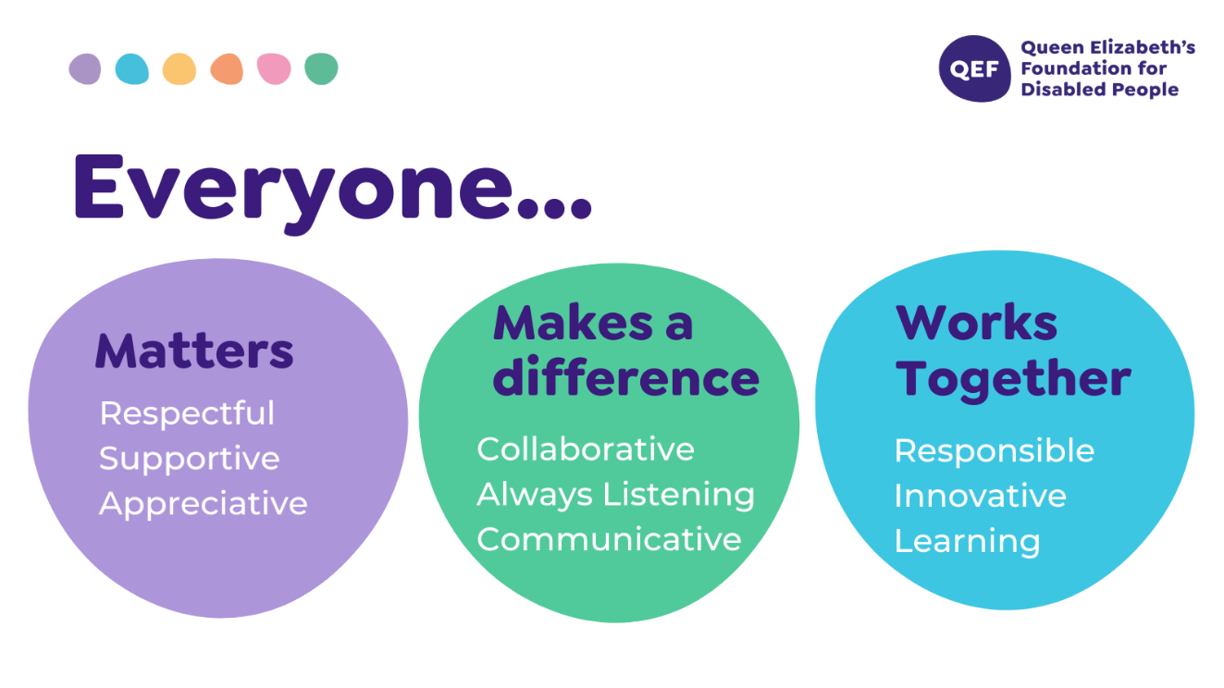
OTHER DUTIES

- You are expected to perform various tasks as necessitated by your changing role within QEF and the charity’s overall business objectives as reasonably requested by your designated manager or the CEO.
- You must read and ensure you understand the current versions of QEF’s policies and procedures and undertake to act in accordance with them at all times.
- You may be required to work at other locations in accordance with the responsibilities and duties of your role.
- The above is not an exhaustive list of duties and may be subject to change.

PERSON SPECIFICATION

Job title | Occupational Therapist
Service | Mobility Services
QUALIFICATIONS AND TRAINING |  | ESSENTIAL | DESIREABLE
Diploma or Degree in Occupational Therapy |  | √
Membership of Health Professionals council |  | √
Evidence of relevant post graduate courses/continual professional development |  | √
Membership of BAOT/COT |  | √
Driver with full driving licence |  | √
Masters module/ qualification |  |  | √
Trained in MoCA & Rookwood |  |  | √
EXPERIENCE and SKILLS
Post qualification experience of working with physical disability and neurological rehabilitation |  | √
Experience in working with complex physical conditions |  |  | √
Experience of assessing for and ordering/prescribing/fitting  equipment and adaptations |  | √
Experience in administering standardised assessments and clinical reasoning in choosing appropriate assessments including home visits |  | √
Experience with manual handing |  | √
Experience in complex manual handling procedures |  |  | √
Experience in composing risk assessments |  | √
Confident with the use of assistive equipment |  |  | √
Experience of working in a multidisciplinary team |  | √
Experience in developing standards and application of national guidelines to clinical practice |  | √
Excellent written and verbal communication skills including use of Microsoft Word, PowerPoint, Excel and Outlook |  | √
Can use own initiative to prioritise caseload and use clinical reasoning to make sound decisions and problem solve |  | √
Knowledge and skills using different models or frameworks |  |  | √
Knowledge of neurological national clinical guidelines |  | √
Knowledge of infection control |  | √
Knowledge of clinical governance |  | √
Have an empathetic approach with the ability to remain objective |  | √
PERSONAL ATTRIBUTES
Ability to demonstrate efficient, effective self-management including use of time, organisation, planning and problem solving, and managing stress of self and clients |  | √
Ability to use own initiative but ask for assistance where appropriate |  | √
Ability to work flexibly and proactively to meet the needs of a varied clinical caseload |  | √
Able to use self-reflection to improve clinical skills |  | √
To respond effectively to constructive feedback |  | √
Commitment to continuous professional development |  | √
To be empathetic and passionate in working with clients with complex physical, cognitive and psychosocial needs and their families |  | √

