JOB DESCRIPTION

Job Title | Care and Rehabilitation Support Worker
Hours | 37.5 hours per week FTE
Department | Care and Rehabilitation
Location Care & Rehabilitation Centre, Woodlands Road, Leatherhead (KT22 0BN)

QEF & ITS FAMILY OF CHARITIES

QEF is a Surrey based charity committed to providing life-transforming services that enable people with disabilities to increase their independence and achieve their goals in life.

We work with over 10,000 disabled children and adults every year with physical or learning disabilities or acquired brain injuries. Whether it’s gaining new skills to live independently, rehabilitation after a brain injury or stroke, or improving independence through increased mobility and accessible holidays; QEF helps disabled people to fulfil their potential in life.

QEF is structured into two main services - Mobility Services who operate outreach services across the South East of England), Care and Rehabilitation Center located within our Leatherhead in Surrey campus. These are augmented by QEF Retail Trading (15 retail charity shops) and a family of smaller charities - MERU which provides innovative product solutions for Children and The Grange in Kent a residential care home for adults with a learning disability.

ROLE CONTEXT

At QEF Care and Rehabilitation Centre (‘CRC’) we offer rehabilitation to clients after a stroke or brain injury or other illnesses as well as provide complex neurological care. Our specialist multi-disciplinary team provides residential or outpatient therapies to those with physical, cognitive and/or communication disabilities, which may also include mild to moderate behavioral problems.

We have a diverse range of one-to-one support programs, tailored to help improve social and functional abilities as well as support for that important move home and back to education or work.

JOB PURPOSE

To provide a comprehensive, integrated 'person-centred' service, our aim is to reflect and respect the individual needs of our clients, ensuring their dignity, autonomy, and choice. We are committed to fostering independence within a supportive environment and delivering exceptional specialist care and rehabilitation.
Our focus is on enhancing the quality of life for our clients and residents through compassionate support and tailored therapeutic interventions.
ROLE RESPONSIBILITIES

- Work collaboratively to establish a caring, safe, responsive, and welcoming atmosphere that promotes the rights, safety, and welfare of those we serve.
- Adhere to the quality standards of the Care Quality Commission and the QEF policy framework, providing high-standard personal care and support with daily living skills respectfully and sensitively.
- To monitor the physical and emotional well-being of the people you support and raise concerns
- Protect and effectively communicate the interests and rights of residents, actively engaging as a keyworker in the Care Planning process.
- Participate in goal setting, rehabilitation planning, discharge meetings, and multidisciplinary team meetings (MDMs), bringing a collaborative spirit to the development and execution of bespoke care and rehabilitation treatment plans.
- Plan and conduct stimulating activities that fulfil the diverse needs and preferences of individuals, ensuring a rich and enjoyable program of engagement.
- Uphold safety policies and procedures, contributing to the development of support plans and risk assessments.
- Assist with general household duties, helping clients manage their personal spaces and communal areas.
- Engage in staff meetings and service evaluations, providing valuable input to continually enhance service delivery.
- Act as an integral team member within a multidisciplinary framework, maintaining effective communication within the service, the organization, and with external stakeholders.

BEING PART OF QEF MEANS

- Actively participating in learning, development and feedback opportunities and cycles as required by QEF’s policies and procedures.
- Acting in accordance with relevant legislative and regulatory requirements as may apply from time to time.
- Supporting and encouraging the involvement of volunteers.
- Promoting QEF’s Equal Opportunities policy and avoiding any behaviour that either directly or indirectly discriminates against others on the grounds of any protected characteristic.
- Taking Health and Safety duties seriously to ensure your safety and that of your colleagues and our residents and clients.
- Being an active team player and attending team meetings and briefings to which you are invited.
- QEF is committed to safeguarding and promoting the welfare of children and adults at risk and expects all staff and volunteers to share this commitment. All staff and volunteers must be responsible and accountable for their safeguarding practice and proactive in identifying and reporting safeguarding concerns.
- Being an ambassador of QEF’s Values and Behaviours in your approach to your role and to our staff, clients, and residents.

VALUES AND BEHAVIOURS
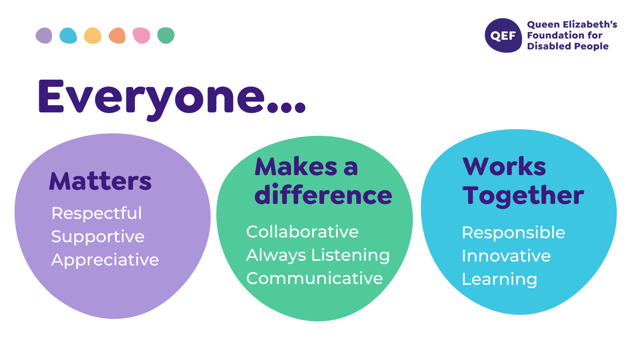
OTHER DUTIES

- You are expected to perform various tasks as necessitated by your changing role within QEF and the charity’s overall business objectives as reasonably requested by your designated manager or the CEO.
- You must read and ensure you understand the current versions of QEF’s policies and procedures and undertake to act in accordance with them at all times.
- You may be required to work at other locations in accordance with the responsibilities and duties of your role.
- The above is not an exhaustive list of duties and may be subject to change.

PERSON SPECIFICATION

Job title : Care and Rehabilitation Support Worker
Service: CRC
QUALIFICATIONS AND TRAINING |  | ESSENTIAL | DESIREABLE
A Level 2 qualification in Health and Social Care or equivalent |  |  | Desirable
Levels of numeracy & literacy equivalent to GCSE (A-C) or NVQ Level 2 (or by test), or the willingness to acquire these skills. |  | Essential
Experience of working with people with physical and/or learning disabilities |  |  | Desirable
Moving and handling, first aid training, or the ability to acquire these skills |  | Essential
Full UK driving licence
KNOWLEDGE AND SKILLS |  | ESSENTIAL | DESIREABLE
Able to understand the rights and needs of adults with a disability, showing empathy |  | Essential
Able to provide person centred care |  | Essential
Able to work as part of a team but also can work on own initiative |  | Essential
Able to follow written and verbal instructions |  | Essential
Able to challenge poor practice and suggest improvements |  | Essential
Knowledge of Safeguarding principles |  |  | Desirable
Able to communicate effectively with a range of people using a variety of methods |  | Essential
Ability to build appropriate relationships with residents, families and relevant others |  | Essential
Able to support and participate in recreational activities inside and outside the home |  | Essential
EXPERIENCE |  | ESSENTIAL | DESIREABLE
Experience of using Microsoft Office applications including Word, Excel and Outlook |  |  | Desirable
Work or voluntary experience of working with young adults with disabilities |  |  | Desirable
Experience of personal care |  |  | Desirable
Experience of implementing a recreational or social activity with a group of young people |  |  | Desirable
PERSONAL ATTRIBUTES |  | ESSENTIAL | DESIREABLE
Ability to work flexible and unsociable hours |  | Essential
Ability to remain calm under pressure |  | Essential
Be prepared to attend training and develop own skills and knowledge |  | Essential
Promotes the organisation positively and works with the values |  | Essential
Ability to develop and maintain positive working relationships |  | Essential
Work in line with the QEF values and behaviours |  | Essential
Able to demonstrate commitment to QEF’s Values & Behaviours |  | Essential
There is an amount of manual handling involved therefore a good level of physical fitness is required in order to carry out the requirements of the residents.

