JOB DESCRIPTION

Job Title | Driving Assessor – clinical role
Hours | 37.5 hours per week (37.5 hours per week FTE)
Department | Mobility Services
Location | Southampton
Level | Band 6
Reports to | Senior Occupational Therapist
Responsible for | Delivering assessments for driving, vehicle adaptations, and passenger transfer into a vehicle

QEF & ITS FAMILY OF CHARITIES

QEF is a Surrey based charity committed to providing life-transforming services that enable people with disabilities to increase their independence and achieve their goals in life.

We work with over 10,000 disabled children and adults every year with physical or learning disabilities or acquired brain injuries. Whether it’s gaining new skills to live independently, rehabilitation after a brain injury or stroke, or improving independence through increased mobility and accessible holidays; QEF helps disabled people to fulfil their potential in life.

QEF is structured into two main services - Mobility Services ( who operate outreach services across the South/South East of England), Care and Rehabilitation Center located within our Leatherhead in Surrey campus. These are augmented by QEF Retail Trading (15 retail charity shops) and a family of smaller charities - MERU which provides innovative product solutions for Children and The Grange in Kent a residential care home for adults with a learning disability.

ROLE CONTEXT

Endorsed by the Department for Transport, QEF Mobility Services is one of the UK’s top 2 providers and, complete over 1,700 mobility assessments each year. They also provide advice and training with adaptations and solutions to ensure maximum mobility.
Driving Ability Assessments objectively measure the capability to drive safely; suitable for those returning to driving, older people at licence renewal or those requiring clarification if there is any concern. We also provide advice and training with adaptations and solutions to ensure maximum mobility.

Passenger assessments provide independent advice on suitable equipment to remove or minimise the risks of manual handling to ensure safe and comfortable transfer of individuals and their equipment into a vehicle. This includes travel by air.

Wheelchair and scooter assessments provide independent assessment through trial of a variety of equipment to identify the most suitable for individual’s needs.

JOB PURPOSE

- To provide a quality assessment service for people with reduced mobility caused by disability, illness or age.
- To be a proactive member of our existing Clinical Team.
- To provide high-quality assessments using clinical knowledge and applying client centred principles.
- To work to ensure all client interaction is provided in compliance with QEF policies.
- To work as a team with other disciplines respecting their professional guidelines and opinions.

ROLE RESPONSIBILITIES

- To assess clients for a range of services, including;
  - Driving Ability – objectively measuring the capability to drive safely.
  - Car Adaptation – advising on controls, seating and posture requirements and vehicle access.
  - Driving from a wheelchair and wheelchair accessible vehicles.
  - Hi-tech solutions for those requiring specialised controls.
  - Vocational assessments for taxi drivers, bus drivers and lorry drivers.
  - Transfer and seating needs for adults or children, trial of equipment and advice on seating and posture.
- Assist in the preparation and delivery of internal/external training courses for professionals and others, and participate in the delivery of in-service training for staff.

BEING PART OF QEF MEANS

- Actively participating in learning, development and feedback opportunities and cycles as required by QEF’s policies and procedures.
- Acting in accordance with relevant legislative and regulatory requirements as may apply from time to time.
- Supporting and encouraging the involvement of volunteers.
- Promoting QEF’s Equal Opportunities policy and avoiding any behaviour that either directly or indirectly discriminates against others on the grounds of any protected characteristic.
- Taking Health and Safety duties seriously to ensure your safety and that of your colleagues and our residents and clients.
- Being an active team player and attending team meetings and briefings to which you are invited.
- QEF is committed to safeguarding and promoting the welfare of children and adults at risk and expects all staff and volunteers to share this commitment. All staff and volunteers must be responsible and accountable for their safeguarding practice and proactive in identifying and reporting safeguarding concerns.
- Being an ambassador of QEF’s Values and Behaviours in your approach to your role and to our staff, clients, and residents.

VALUES AND BEHAVIOURS
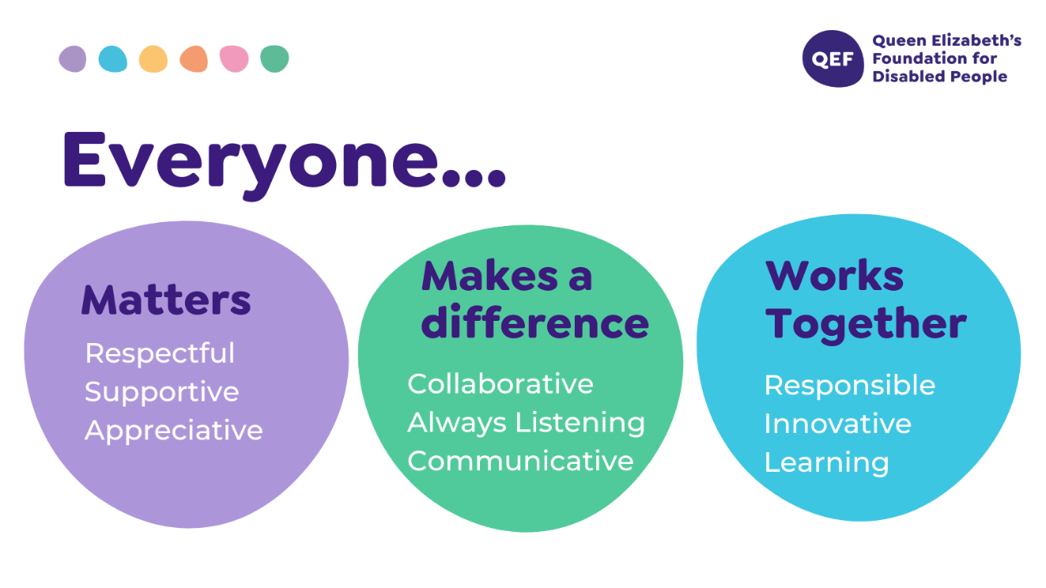
OTHER DUTIES

- You are expected to perform various tasks as necessitated by your changing role within QEF and the charity’s overall business objectives as reasonably requested by your designated manager or the CEO.
- You must read and ensure you understand the current versions of QEF’s policies and procedures and undertake to act in accordance with them at all times.
- You may be required to work at other locations in accordance with the responsibilities and duties of your role.
- The above is not an exhaustive list of duties and may be subject to change.

PERSON SPECIFICATION

Job title | Driving Assessor – clinical role (Band 6)
QUALIFICATIONS AND TRAINING |  | ESSENTIAL | DESIRABLE
Diploma or degree in Occupational Therapy or Physiotherapy or Other clinical qualification |  | √
Membership of NMC, HCPC or other regulatory body |  | √
Membership of professional body e.g. BAOT/COT/ |  | √
Driver with full driving licence |  | √
Trained in MoCA, Rookwood, or other cognitive assessment toolkits |  | √
KNOWLEDGE AND SKILLS
Can use own initiative to prioritise caseload and use clinical reasoning to make sound decisions and problem solve |  | √
Excellent written and verbal communication skills including use of Microsoft Word, PowerPoint, Excel and Outlook |  | √
Knowledge of clinical governance |  | √
Knowledge of infection control |  | √
Knowledge of neurological national clinical guidelines |  |  | √
EXPERIENCE
Experience in administering standardised assessments and clinical reasoning in choosing appropriate assessments |  | √
Post qualification experience of working with clients with physical disability and neurological rehabilitation. |  | √
Experience of assessing for and ordering/prescribing/fitting  equipment and adaptations |  | √
Experience with manual handing |  | √
Experience in composing risk assessments |  | √
Experience of working in a multidisciplinary team |  | √
Experience in working with people with complex conditions |  | √
PERSONAL ATTRIBUTES
Ability to demonstrate efficient, effective self-management including use of time, organisation, planning, problem solving, and managing stress of self and clients |  | √
Ability to use own initiative but ask for assistance where appropriate |  | √
Ability to work flexibly and proactively to meet the needs of a varied clinical caseload |  | √
Able to use self-reflection to improve clinical skills |  | √
To respond effectively to constructive feedback |  | √
Commitment to continuous professional development |  | √
To be empathetic and passionate in working with clients and families, with complex physical, cognitive and psychosocial needs |  | √

