JOB DESCRIPTION

Job Title | Shop Assistant
Department | Retail Trading
Reports to | Shop Manager
Responsible for

JOB PURPOSE

- QEF Retail Trading has a network of retail shops throughout Surrey and Middlesex that sell a wide range of donated goods (clothing, bric-a-brac, toys & games) all at bargain prices. The shops are each run by a shop manager and supported by area managers and a great team of volunteers. In some locations a paid assistant is employed to deputise in the manager’s absence.
- To work closely with the shop manager, undertaking specific duties as requested and deputising in his/her absence
- To ensure the shop operates effectively and achieve its maximum trading potential
- To maintain a high standard of presentation in the shop, ensuring that regular rotation of stock is carried out in line with current company procedures

ROLE RESPONSIBILITIES

Operations:
- To maintain all administrative systems and ensure proper cash handling in accordance with QEF accounting and security procedures
- Provide a safe environment that protects all people (shop and public) from harm
- To comply with all current legislation, organisational policies & procedures and promotions
- To take and achieve the standard Health & Safety courses supplied
Revenue:
- To process Gift Aid legally and properly
- To maximise sales to achieve the sale target

Stock:
- To sort and price donated stock. (adhering closely to pricing guidelines)
- Ensure that all products sold in the shop are compliant with current Trading Standards
- Ensure that waste and Rag items are dealt with in line with current QEF procedures

People:
- Provide excellent customer service to QEF’s customers
- Support the volunteer team to ensure that they are motivated, effective and well informed
Security:
- To ensure that the premises are secure, and that the shop is a safe place to work in
- To inform relevant bodies when there has been, or suspicion of, a breach of any security procedures
- To ensure that all money handling procedures and accounting procedures are being followed & actioned correctly

General:
- At all times to project a positive and professional image of QEF

BEING PART OF QEF MEANS

- Actively participating in learning, development and feedback opportunities and cycles as required by QEF’s policies and procedures.
- Acting in accordance with relevant legislative and regulatory requirements as may apply from time to time.
- Supporting and encouraging the involvement of volunteers.
- Promoting QEF’s Equal Opportunities policy and avoiding any behaviour that either directly or indirectly discriminates against others on the grounds of any protected characteristic.
- Taking Health and Safety duties seriously to ensure your safety and that of your colleagues and our residents and clients.
- Being an active team player and attending team meetings and briefings to which you are invited.
- QEF is committed to safeguarding and promoting the welfare of children and adults at risk and expects all staff and volunteers to share this commitment. All staff and volunteers must be responsible and accountable for their safeguarding practice and proactive in identifying and reporting safeguarding concerns.
- Being an ambassador of QEF’s Values and Behaviours in your approach to your role and to our staff, clients, and residents.

VALUES AND BEHAVIOURS
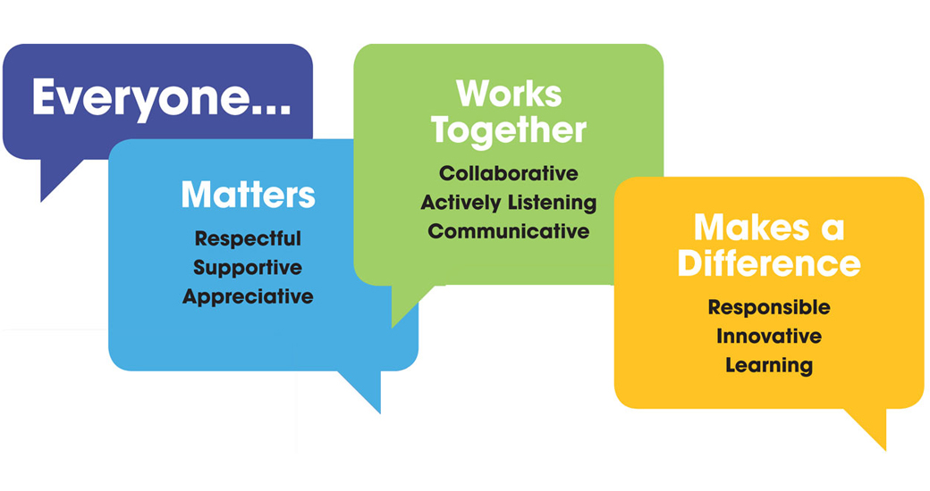
OTHER DUTIES

- You are expected to perform various tasks as necessitated by your changing role within QEF and the charity’s overall business objectives as reasonably requested by your designated manager or the CEO.
- You must read and ensure you understand the current versions of QEF’s policies and procedures and undertake to act in accordance with them at all times.
- You may be required to work at other locations in accordance with the responsibilities and duties of your role.
- The above is not an exhaustive list of duties and may be subject to change.

PERSON SPECIFICATION

Job title | Shop Assistant
Department | Retail Trading
QUALIFICATIONS AND TRAINING |  | ESSENTIAL | DESIRABLE
Levels of numeracy & literacy equivalent to GCSE (A-C) or NVQ Level 2 (or by test), or the willingness to acquire these skills |  |  | Y
or in the absence of formal qualifications relevant retail experience |  | Y
KNOWLEDGE AND SKILLS
Good level of verbal communication |  |  | Y
Ability to motivate and support volunteers |  | Y
Basic IT skills |  |  | Y
EXPERIENCE
Retail experience |  | Y
Charity retail experience |  | Y
PERSONAL ATTRIBUTES
Demonstrable ability to be an ambassador of QEF’s Values & Behaviours |  | Y
The job could be physically taxing moving donations |  | Y
Flexibility to work the hours required |  |  | Y

