JOB DESCRIPTION

Job Title: | Speech and Language Therapy Lead
Department: | Therapies
Location: | QEF Care and Rehab Centre  Woodlands Road,  Leatherhead  KT22 0BN
Reports to: | Head of Clinical Services

QEF & ITS FAMILY OF CHARITIES
QEF is a Surrey based charity committed to providing life-transforming services that enable people with disabilities to increase their independence and achieve their goals in life.

We work with over 5,000 disabled children and adults every year with physical or learning disabilities or acquired brain injuries. Whether it’s gaining new skills to live independently, rehabilitation after a brain injury or stroke, or improving independence through increased mobility and accessible holidays; QEF helps disabled people to fulfil their potential in life.

QEF is structured into different services – Mobility and Rehabilitation Services. These are augmented by QEF Retail Trading and a family of smaller charities - MERU which provides innovative product solutions; Sutton Shopmobility and VASD which offer access to and loans of mobility equipment.

ROLE CONTEXT
QEF Care and Rehab Centre is a brand new, state of the art 48 bedded rehab centre. We offer four different client pathways to include Neuro Rorehabilitation, General Rehabilitation, Longer Term Care and Day / Out Patient Servcies. We support clients following a stroke, other aquired brain injury, those with neurological conditions and those with a general decline in functioning following a period of illness or hospital stay. We have a large multi-disciplinary team who provide therapies to those clients who present with physical, cognitive and/or communication disabilities, which may also include mild to moderate behavioural problems.

This is an exciting senior leadership opportunity for an experienced and skilled Speech & Language Therapist (SLT) to come and lead our Speech and Language Therapy team at the QEF Care and Rehabilitation Centre. The role is full time, a permanent position at 37.5 hours per week.

The post holder will provide positive and visible leadership through a collaborative, creative, motivational, and problem-solving approach. They will drive a culture of continuous quality improvement, innovation and best patient experience through a highly professional approach.

In this role, you will have a diverse range of clients, in which you will need to provide high quality Speech and Language Therapy assessment, clinically relevant treatment interventions and implement plans for one-to-one support programmes, tailored to help improve social and functional abilities as well as support for that important move home.

JOB PURPOSE

The post holder will report to the Head of Clinical Services and is an important senior position within the leadership structure of the QEF Care and Rehab Centre. They will be responsible to deliver speech and language therapy leadership including supervision and yearly performance reviews. The post holder is required to ensure the effective provision of high standard Speech and Language Therapy services including safe standards and evidence based clinical practices. You will be required to work as a senior member of the multi-disciplinary team and to provide training and advice to other professionals, families and carers.

ROLE RESPONSIBILITIES
- Reporting to the Head of Clinical Services you will hold accountability and responsibility for the SLT provision to all clients within our rehabilitation centre.
- Leading and managing a specialist SLT team in a brand new state of the art rehabilitation centre. The team comprises band 6 and band 5 SLTs, an SLT assistant and we are proactive to have students.
- To contribute to the continued development of a high quality SLT therapeutic service
- To provide specialist dysphagia assessment and intervention to clients who require, utilising compotenceis and experience at a senior practitioner level.
- To provide highly skilled communication assessment and intervention to all our clients with acquired brain injury, such as stroke, ABI and other neurological conditions, utilising compotenceis and experience at a senior practitioner level.
- Delivering 1:1 and group SLT sessions to a range of clients and creating accessible communication and swallowing guidance for the wider MDT.
- Conducting skilled mental capacity assessments independently or jointly with other professionals, as appropriate.
- Having a ‘key-worker’ role – managing and overseeing a specific client’s whole journey at QEF, liasing with families, being a single point of contact for all queries, co-ordinating care and discharge packages.
- Advocating on clients’ behalf in a range of situations, eg. when writing reports, CHC forms and complex DST meetings where highly skilled reporting and ability to deal with questioning is necessary.
- Closely working with the wider multi-disciplinary team – PTs, OTs, Psychology team, dietitian, nursing, carers, kitchen staff, activity co-ordinators. Also working with outside agencies, such as social workers, safeguarding, expert witnesses, lawyers, neuro-navigators, DST assessors.
- Working with the Head of Clinical Services and senior management on service development, quality improvement projects and clinical audit
- Providing clinical supervision and expert advice to SLT staff as well as SLT students on placement.
- Responsible for the recruitment within the SLT department with opportunity to support in the recruitment process of the wider CRC staffing remit
- Managing the Speech and Language Therapy team to include sickness absence, performance, appraisals, probationary periods in line with QEF policy
- Supporting and leading on the emphasis on learning and reflective practice – within the SLT as well as wider team, providing and participating in training and learning.
- Actively jointly working with our catering company, manager and dietitian to provide high standard of catering in line with IDDSI framework

BEING PART OF QEF MEANS
- Actively participating in learning, development and feedback opportunities and cycles as required by QEF’s policies and procedures.
- Acting in accordance with relevant legislative and regulatory requirements as may apply from time to time.
- Supporting and encouraging the involvement of volunteers.
- Promoting QEF’s Equal Opportunities policy and avoiding any behaviour that either directly or indirectly discriminates against others on the grounds of any protected characteristic.
- Taking Health and Safety duties seriously to ensure your safety and that of your colleagues and our residents and clients.
- Being an active team player and attending team meetings and briefings to which you are invited.
- QEF is committed to safeguarding and promoting the welfare of children and adults at risk and expects all staff and volunteers to share this commitment. All staff and volunteers must be responsible and accountable for their safeguarding practice and proactive in identifying and reporting safeguarding concerns.
- Being an ambassador of QEF’s Values and Behaviours in your approach to your role and to our staff, clients, and residents.

VALUES AND BEHAVIOURS
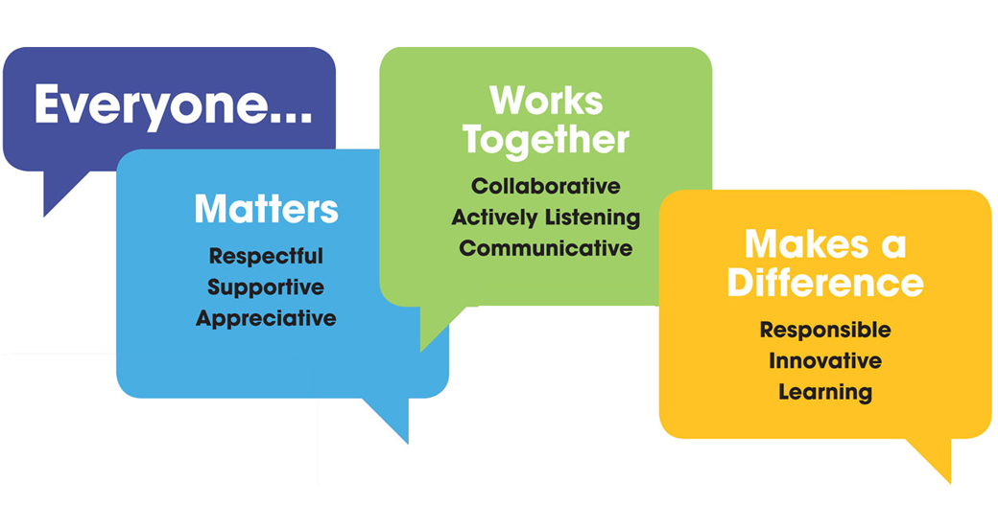
OTHER DUTIES
- You are expected to perform various tasks as necessitated by your changing role within QEF and the charity’s overall business objectives as reasonably requested by your designated manager or the CEO.
- You must read and ensure you understand the current versions of QEF’s policies and procedures and undertake to act in accordance with them at all times.
- You may be required to work at other locations in accordance with the responsibilities and duties of your role.
- The above is not an exhaustive list of duties and may be subject to change.

PERSON SPECIFICATION

Job title: | Speech and Language Therapy Lead
Department: | Speech and language Therapy
QUALIFICATIONS AND TRAINING |  | ESSENTIAL | DESIRABLE
Degree in Speech & Language Therapy. |  | Y
Additional training in Dysphagia. |  | Y
Ongoing CPD record relevant to TBI. |  | Y
Ongoing membership with the RCSLT. |  | Y
Registration with HCPC |  | Y
Further training/ Qualification relevant to Neuro-rehabilitation. |  |  | Y
KNOWLEDGE AND SKILLS
A good standard of literacy and numeracy. |  | Y
Excellent written and verbal communication skills. |  | Y
Competent in Microsoft Word, Excel and Outlook. |  | Y
Good decision making and problem solving skills. |  | Y
Excellent clinical skills |  | Y
Ability to manage a small team of Speech and Language Therapists |  | Y
Training skills |  |  | Y
Team working |  | Y
Excellent knowledge of neuro speech and language therapy |  | Y
Knowledge of augmentative and alternative communication |  | Y
Networking abilities within the profession |  |  | Y
Quality assurance |  |  | Y
Outcome measures |  |  | Y
EXPERIENCE
Experience with adult neurologically impaired adults. |  | Y
Experience of management at least at team/middle management level. |  |  | Y
Working with carers. |  | Y
PERSONAL ATTRIBUTES
Assertiveness/adaptability |  | Y
Ability to manage and deal with change |  | Y
Ability to use own initiative |  | Y
Willingness and ability to work within the ethos of the Service |  | Y
Good time management |  | Y

