JOB DESCRIPTION

Job Title: | Speech and Language Therapist (Band 6 equivalent)
Department: | Therapies
Reports to: | Lead SLT

ROLE CONTEXT
At QEF Care and Rehabilitation Centre we offer neurorehabilitation and transitional support to clients after a stroke or other acquired brain injury. Our specialist multi-disciplinary team provides residential or outpatient therapies to those with physical, cognitive and/or communication disabilities, which may also include mild to moderate behavioural problems.

We have a diverse range of one-to-one support programs, tailored to help improve social and functional abilities as well as support for that important move home and back to education or work.

JOB PURPOSE
- To provide a speech and language therapy service to adults with acquired communication, cognitive and/or swallowing problems.
- To offer neurorehabilitation in a residential setting to adult clients, providing intervention on an individual or group basis as required.
- To provide specialist speech, language and swallowing assessments and neurorehabilitation to clients on the stroke pathway adhering to local and governmental policies.
- To provide specialist speech, language and swallowing assessments and neurorehabilitation to people as out-patients as required.
- To have a responsibility for developing SLT programmes and services for clients within NRS, under the guidance of the Senior Speech and Language Therapists.
- To provide advice to clients, their families and relevant staff on the management of dysphagia.
- To contribute to the monitoring and achievement of relevant standards.

ROLE RESPONSIBILITIES
- To hold responsibility for own caseload and be responsible for a defined area of the service, working without direct supervision.
- To work as a member of the multi-disciplinary neuro-rehabilitation team, contributing to the planning, development and delivery of an effective and efficient service.
- To contribute, as a member of the speech and language therapy team, to the evaluation and audit of practice. This may lead to the implementation of specific changes to practice or contribute to service protocols/care pathways.
- To liaise with other involved agencies and with clients and carers to provide an integrated service.

BEING PART OF QEF MEANS
- Actively participating in learning, development and feedback opportunities and cycles as required by QEF’s policies and procedures.
- Acting in accordance with relevant legislative and regulatory requirements as may apply from time to time.
- Supporting and encouraging the involvement of volunteers.
- Promoting QEF’s Equal Opportunities policy and avoiding any behaviour that either directly or indirectly discriminates against others on the grounds of any protected characteristic.
- Taking Health and Safety duties seriously to ensure your safety and that of your colleagues and our residents and clients.
- Being an active team player and attending team meetings and briefings to which you are invited.
- QEF is committed to safeguarding and promoting the welfare of children and adults at risk and expects all staff and volunteers to share this commitment. All staff and volunteers must be responsible and accountable for their safeguarding practice and proactive in identifying and reporting safeguarding concerns.
- Being an ambassador of QEF’s Values and Behaviours in your approach to your role and to our staff, clients, and residents.

VALUES AND BEHAVIOURS

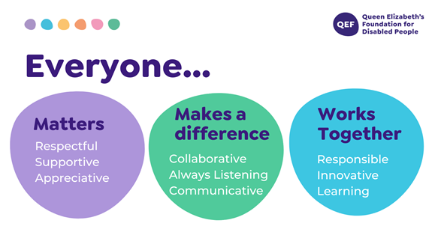

OTHER DUTIES

- You are expected to perform various tasks as necessitated by your changing role within QEF and the charity’s overall business objectives as reasonably requested by your designated manager or the CEO.
- You must read and ensure you understand the current versions of QEF’s policies and procedures and undertake to act in accordance with them at all times.
- You may be required to work at other locations in accordance with the responsibilities and duties of your role.
- The above is not an exhaustive list of duties and may be subject to change.

PERSON SPECIFICATION

Job title: | Speech and Language Therapist (Band 6 equivalent)
Service: | Therapies
QUALIFICATIONS AND TRAINING |  | ESSENTIAL | DESIREABLE
Diploma or degree leading to the RCSLT Certificate to Practice |  | Y
Registered member of RCSLT |  | Y
Having a licence to practice with the Healthcare Professions Council |  | Y
Membership of relevant Clinical Excellence Networks |  |  | Y
KNOWLEDGE AND SKILLS
Excellent verbal and written communication skills |  | Y
Able to work collaboratively with the multidisciplinary team |  | Y
Able to work as part of a team and independently as required
Good IT skills |  | Y
Awareness and sensitivity to the needs of clients from a range of ethnic and linguistic backgrounds |  | Y
Able to write good accurate notes and reports |  | Y
Ability to prioritise, good time management and organisational skills |  | Y
Understanding of, and ability to implement, National policies and procedures relevant to the client group |  | Y
Working knowledge of the principles of Clinical Governance |  | Y
EXPERIENCE
Experience of neurorehabilitation to a specialist level |  | Y
Management of all aspects of acquired neurological dysphagia |  | Y
Experience of working in a multi-disciplinary team |  | Y
Confident in administering specialist neurological assessments |  |  | Y
Knowledge of use of computer software in treatment of dysphasia and dysarthria |  |  | Y
Experience of assessment for, and use of, a range of Alternative and Augmentative Communication systems |  |  | Y
Proven ability to work with, and supervise, assistants |  |  | Y
PERSONAL ATTRIBUTES
Ability to demonstrate empathy, sensitivity and tact to a diverse client group |  | Y
Highly motivated with a strong client focussed approach |  | Y
Flexible |  | Y
Ability to carry out concurrent activities with regular interruption |  | Y
Proactive approach to service delivery |  | Y
Team player |  | Y
Able to demonstrate commitment to QEF’s Values & Behaviours |  | Y
Excellent inter-personal skills, including observation and listening |  | Y

