JOB DESCRIPTION & PERSON SPECIFICATION

JOB DESCRIPTION

Job Title | Events, Community and Partnerships Manager
Department | Engagement and Partnerships
Location | Leatherhead Court
Reports to | Assistant Director of Events, Community, Partnerships and Trusts
Responsible for | Senior Events, Community and Partnerships Executive, Senior Special Events Executive

ROLE CONTEXT

The QEF Engagement and Partnerships team is based at Leatherhead Court. The team raise money to support all QEF services and the activities of the family of charities, through a combination of individual giving campaigns, events, community and corporate support and major gifts.

As a Manager within the Engagement and Partnerships team, the Events, Community and Partnerships Manager will be responsible for generating income from events, community activities and corporate fundraising. Taking a strategic approach to the development and management of these three fundraising areas, with support from your Assistant Director.

As the Events, Community and Partnerships Manager, you will be responsible for leading the team to successfully deliver their income targets and KPI’s in each area.

Working closely with your Senior Executives and Assistant Director, you will produce your strategy and budgets for each Financial Year. You will monitor team performance through KPI updates, the RAG and narratives for the Management Accounts

You will be a proactive, dynamic and enthusiastic individual with experience in organising high profile events and a track record of developing income streams. You will be able to juggle a number of different projects and will possess a passion for succeeding in creating unique and exciting ways to give.

You will manage the Senior Special Events Executive and the Senior Events, Community and Partnerships Executive to ensure the successful delivery of QEF’s portfolio of annual special events programme, the challenge events portfolio and community programme - that includes Gala Dinner, Celebration of British Wines, Guinness and Oysters (Mansion House), The London Marathon, Asics 10km and more.

You will currently oversee corporate relationships and income, but this will move over to a Corporate Executive at a later stage in the restructure.

JOB PURPOSE

To lead the Events, Community and Partnerships team (including Special Events) , develop and explore new opportunities to meet QEFs vision and strategy.

The Events, Community and Partnerships Manager is responsible for developing, implementing and managing a range of exciting fundraising events, developing community infrastructure and engaging local companies that can help raise the public profile of QEF and achieve income growth.

The role will work with the Assistant Director to focus on the development and implementation of the Events, Community and Partnerships strategy that will enable us to successfully meet our income targets.

ROLE RESPONSIBILITIES
Strategy and planning
• Support the Assistant Director to develop and oversee the implementation of a Events, Community and Partnerships strategy which should explore new opportunities, maintain diverse and sustainable income streams, and builds the organisation’s financial capacity to meet its aims and objectives
• To drive innovation and encourage creativity in your team to ensure QEF’s fundraising activities stand out from the crowd
• To lead and support the development of the Events, Community and Partnerships team to ensure that opportunities to secure income for the QEF network are maximised
• To report on income and expenditure, analyse activities to inform the strategy and assess progress against targets.

Leadership and management
- To lead and manage the Events, Community and Partnerships team and coordinate its activities with the support of the Assistant Director to meet and exceed the fundraising targets
• To ensure the effective line management of direct line reports in accordance with QEFs PDR process and commitment to staff development, providing regular support and performance monitoring
• To work effectively with the Assistant Director in developing committees and development groups to deliver against the long-term strategy for growth

Relationship management
• To work effectively with key stakeholders across the QEF Group, delivering a coordinated fundraising programme within an agreed framework to engage staff across all areas of our work
• Develop and maintain relationships delivering the required donor care for a positive stewardship journey
• Develop the appropriate resources to ensure that individuals either donating or raising money through events or community activities can be properly supported and recognised

Goal delivery
To be supported by the Assistant Director and work operationally with the Event, Community and Partnerships team to ensure:
- Fundraising targets are monitored and met
- KPI’s are monitored and met
- QEF’s portfolio of Fundraising events are executed at the highest standard with maximum results
- Support the Senior Events Executive in the delivery of a new QEF Gala Dinner (or similar/alternative)
- Support the Event’s Community and Partnerships team in the delivery of QEF’s new Mass Participation Event
- Support the Assistant Director with Wimbledon and IATA partnerships

BEING PART OF QEF MEANS

- Actively participating in learning, development and feedback opportunities and cycles as required by QEF’s policies and procedures.
- Acting in accordance with relevant legislative and regulatory requirements as may apply from time to time.
- Supporting and encouraging the involvement of volunteers.
- Promoting QEF’s Equal Opportunities policy and avoiding any behaviour that either directly or indirectly discriminates against others on the grounds of any protected characteristic.
- Taking Health and Safety duties seriously to ensure your safety and that of your colleagues and our residents and clients.
- Being an active team player and attending team meetings and briefings to which you are invited.
- QEF is committed to safeguarding and promoting the welfare of children and adults at risk and expects all staff and volunteers to share this commitment. All staff and volunteers must be responsible and accountable for their safeguarding practice and proactive in identifying and reporting safeguarding concerns.
- Being an ambassador of QEF’s Values and Behaviours in your approach to your role and to our staff, clients, and residents.

VALUES AND BEHAVIOURS

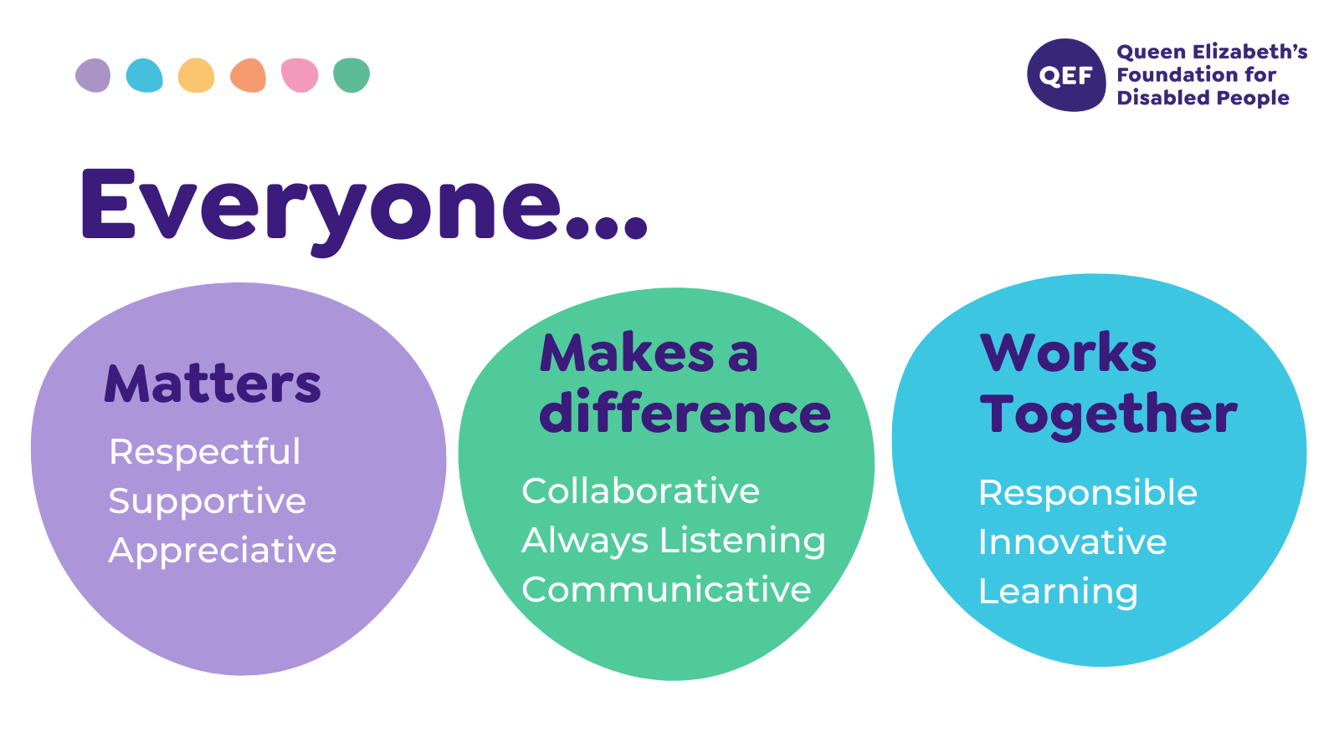

OTHER DUTIES

- You are expected to perform various tasks as necessitated by your changing role within QEF and the charity’s overall business objectives as reasonably requested by your designated manager or the CEO.
- You must read and ensure you understand the current versions of QEF’s policies and procedures and undertake to act in accordance with them at all times.
- You may be required to work at other locations in accordance with the responsibilities and duties of your role.
- The above is not an exhaustive list of duties and may be subject to change.

PERSON SPECIFICATION

Job title | Events, Community and Partnerships Manager
Service | Engagement & Partnerships
QUALIFICATIONS AND TRAINING |  | ESSENTIAL | DESIREABLE
Educated to degree level or equivalent. |  | Y
KNOWLEDGE AND SKILLS
Knowledge of sales and/or marketing techniques and their relevance to fundraising |  | Y
An understanding of the importance of delivering a high-quality client focused service |  | Y
Excellent written and verbal communication skills, with the ability to communicate to, and negotiate with, a wide range of people at all levels |  | Y
Great on the phone building relationships with supporters and on email responding to queries quickly and efficiently |  | Y
Highly motivated, entrepreneurial and target orientated |  | Y
Attention to detail, systematic & process focused |  | Y
Creative, innovative and enthusiastic, with the ability to inspire and motivate others, both internally and externally |  | Y
Highly organised |  | Y
Demonstrable ability to propose, set, manage and monitor income and expenditure budgets |  | Y
Ability to work flexible hours including evenings, weekends and Bank Holidays |  | Y
Excellent interpersonal skills with the ability to work both as part of a team and on your own initiative |  |  | Y
IT literate- experience of using Microsoft Outlook in particular Word, Excel and PowerPoint, familiar with Windows and network environment |  |  | Y
Experience of CRM databases, ideally Raiser’s Edge |  |  | Y
Knowledge of Health & Safety legislation |  |  | Y
EXPERIENCE
Experience of working on a number of projects at once, with good time management ability |  | Y
Experience of organising a gala dinner |  | Y
Experience of website content management systems and social media |  |  | Y
Experience of managing challenge events |  |  | Y
Track record of successfully generating, developing and managing income streams |  | Y
Some experience of organising, co-ordinating and implementing successful fundraising events |  |  | Y
PERSONAL ATTRIBUTES
Demonstrable committed to QEF’s Mission, Vision and Values |  | Y
Proven ability to plan systematically and manage resources in an organised way, prioritising workload and meeting deadlines |  | Y
Excellent organisational and time management skills |  | Y
Full driving licence |  | Y

