JOB DESCRIPTION

Job Title | Housekeeper
Department | Housekeeping
Reports to | Housekeeping Supervisor

JOB PURPOSE

To maintain high standards of cleanliness in clients, staff and visitors’ areas through the carrying out of daily housekeeping duties in accordance with cleaning schedules.

To work within appropriate Health & Safety guidelines and infection control measures.

ROLE RESPONSIBILITIES

- Complete a range of cleaning tasks efficiently and to a high standard within bedrooms, bathrooms, offices and communal space as directed by the Housekeeping Supervisor.

- To undertake inspections of beds, mattresses, furniture and soft furnishings and to action all findings including reporting serious issues to the Housekeeping Supervisor or Registered Manager without delay.

- To ensure soap and towel dispensers are filled and replenished as needed and to report all equipment / furniture / soft furnishing breakages and damage.

- To provide a laundry service to the residents/clients to ensure that a clean, well presented supply of clothes and linen is always available.

- To provide a laundry services to the therapy and the catering department within the service.

- To use commercial cleaning machinery such as carpet/floor cleaners, is required in line with instructions.

- To use cleaning materials (chemicals) as appropriate and in line with safe guidelines.

- To work with the therapy team to support clients with learning how to do their laundry.

- To maintain client confidentiality.

BEING PART OF QEF MEANS

- Actively participating in learning, development and feedback opportunities and cycles as required by QEF’s policies and procedures.
- Acting in accordance with relevant legislative and regulatory requirements as may apply from time to time.
- Supporting and encouraging the involvement of volunteers.
- Promoting QEF’s Equal Opportunities policy and avoiding any behaviour that either directly or indirectly discriminates against others on the grounds of any protected characteristic.
- Taking Health and Safety duties seriously to ensure your safety and that of your colleagues and our residents and clients.
- Being an active team player and attending team meetings and briefings to which you are invited.
- QEF is committed to safeguarding and promoting the welfare of children and adults at risk and expects all staff and volunteers to share this commitment. All staff and volunteers must be responsible and accountable for their safeguarding practice and proactive in identifying and reporting safeguarding concerns.
- Being an ambassador of QEF’s Values and Behaviours in your approach to your role and to our staff, clients, and residents.

VALUES AND BEHAVIOURS
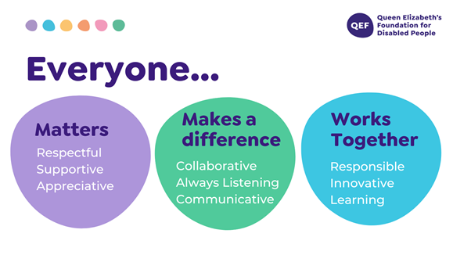
OTHER DUTIES

- You are expected to perform various tasks as necessitated by your changing role within QEF and the charity’s overall business objectives as reasonably requested by your designated manager or the CEO.
- You must read and ensure you understand the current versions of QEF’s policies and procedures and undertake to act in accordance with them at all times.
- You may be required to work at other locations in accordance with the responsibilities and duties of your role.
- The above is not an exhaustive list of duties and may be subject to change.

PERSON SPECIFICATION: Housekeeper

QUALIFICATIONS AND TRAINING | ESSENTIAL | DESIRABLE
H&S awareness and knowledge of COSHH regulations |  | Y
Level 1 cleaning and Support Service Skills or equivalent |  | Y
KNOWLEDGE AND SKILLS
Range of cleaning tasks within bedrooms, bathrooms, offices and communal space. | Y
Able to operate laundry machines, including washer, dryer and commercial iron |  | Y
Knowledge of commercial cleaning machinery such as carpet/floor cleaners |  | Y
Basic repairs (sewing buttons on etc) | Y
EXPERIENCE
Experience in a similar role as a housekeeper / cleaner. |  | Y
An understanding of cleaning materials (chemicals) how to use these safely and appropriately. |  | Y
Able to use cleaning equipment safely, complying with company standards, policies & procedures. |  | Y
Experience of working in a care environment |  | Y
Have worked successfully as part of a team. | Y
Able to work independently and follow instructions. | Y
PERSONAL ATTRIBUTES
A team player also happy to work alone. | Y
A friendly and approachable character. | Y
Have the ability to communicate effectively. | Y
Able to manage own workload and priorities tasks. | Y
A good timekeeper. | Y
Energetic, cheerful with a positive outlook | Y
A flexible approach to ensure tasks are completed when under pressure. | Y
Demonstrable ability to be an ambassador of QEF’s Values & Behaviours | Y

