JOB DESCRIPTION

Job Title | Lead Physiotherapist (Band 7)
Department | Therapies
Reports to | Head of Service
Responsible for | Physiotherapy team

ROLE CONTEXT

At QEF Care and Rehabilitation Centre (CRC) we offer neurorehabilitation to clients after a stroke or other acquired brain injury. Our specialist multi-disciplinary team provides residential therapy and support to those with physical, cognitive and/or communication disabilities, which may also include mild to moderate behavioral problems.

Growing demand for our services, combined with our passion for delivering the highest standards of care and treatment, inspired the move to our new, state-of-the-art Care and Rehabilitation Centre in July 2020. The Centre, especially designed for us, provides a fantastic hub of expertise and technology for people with a wide range of disabilities. It is located next to our head office, Leatherhead Court, in Leatherhead, Surrey.

JOB PURPOSE

To co-operate with the Head Service in providing an effective service to residential clients, carrying out assessment and implementing treatment programmes, evaluating and updating as appropriate. To lead and support the physiotherapy team.
The post-holder will liaise with the Leads and colleagues from other departments, especially the Care and Nursing teams to ensure continuity and consistency re clients’ physical needs and treatment, providing advice and support as necessary.

ROLE RESPONSIBILITIES

- To work as a lead member of the multi-disciplinary neuro-rehabilitation team, contributing to the planning, development, and delivery of an effective and efficient service.
- To take a lead role in assessment, treatment, rehabilitation, and management of residential clients at CRC.
- To carry out holistic, measurable assessments, implementing appropriate treatments, rehabilitation, and management programmes, demonstrating ongoing clinical reasoning, patient evaluation and evidence-based practice.
- Regular use of clinical and patient reported outcome measures and setting appropriate patient centred short- and long- term goals.
- Participate in the key therapist/worker program for clients – providing information to and liaising with clients, families, carers and other involved agencies to facilitate their rehabilitation and ensure safe discharge.
- Assessment for equipment to aid patient’s rehabilitation, treatment and management
- Integrating and monitoring treatment programmes in the clients’ environment whether carried out by therapy support worker, care and support worker staff.
- Carrying out clinical interventions to optimise patient outcome e.g. casting and splinting, FES, orthotic use.
- Supporting the assessment of wheelchair seating requirements for clients in conjunction with the Occupational Therapy department.
- Providing information, based on professional judgements and experience to clients, families, carers and other involved agencies with implications for future provision.
- Maintaining clinical records in line with CSP and HCPC Professional Standards
- Attending specialist clinics where appropriate e.g. spasticity, orthotics, wheelchair clinics.
- Liaising with the patient’s wider team where possible to enable cohesive patient management e.g. GP, NHS teams and specialist clinics, other private therapists.
- To provide informal and formal reports to GP’s, consultants, commissioners, case managers, private health insurers, other health professionals when required for cohesive patient management.
- Supporting the instruction of members of the care and support team regarding moving and handling, transfers, splints, standing and walking, in conjunction with the therapy team.
- To support home visits as required
- Evidence of CPD reflecting acquired knowledge and skills and their application to practice
- Supervising physiotherapy staff and supporting the cascade supervision process.
- To signpost other QEF services for patient management e.g. Mobility Services driving assessments, wheelchair assessment, “try before you fly”.
- Ensuring that all equipment used is in good order and ensuring the safety of clients and staff at all times in accordance with the Health & Safety at Work Act.
- To report any faulty equipment to the CRC maintenance team

BEING PART OF QEF MEANS

- Actively participating in learning, development and feedback opportunities and cycles as required by QEF’s policies and procedures.
- Acting in accordance with relevant legislative and regulatory requirements as may apply from time to time.
- Reporting Safeguarding concerns to QEF Safeguarding leads and/or local authority safeguarding team.
- Supporting and encouraging the involvement of volunteers.
- Promoting QEF’s Equal Opportunities policy and avoiding any behaviour that either directly or indirectly discriminates against others on the grounds of any protected characteristic.
- Taking Health and Safety duties seriously to ensure your safety and that of your colleagues and our residents and clients.
- Being an active team player and attending team meetings and briefings to which you are invited.
- QEF is committed to safeguarding and promoting the welfare of children and adults at risk and expects all staff and volunteers to share this commitment. All staff and volunteers must be responsible and accountable for their safeguarding practice and proactive in identifying and reporting safeguarding concerns.
- Being an ambassador of QEF’s Values and Behaviours in your approach to your role and to our staff, clients, and residents.

VALUES AND BEHAVIOURS
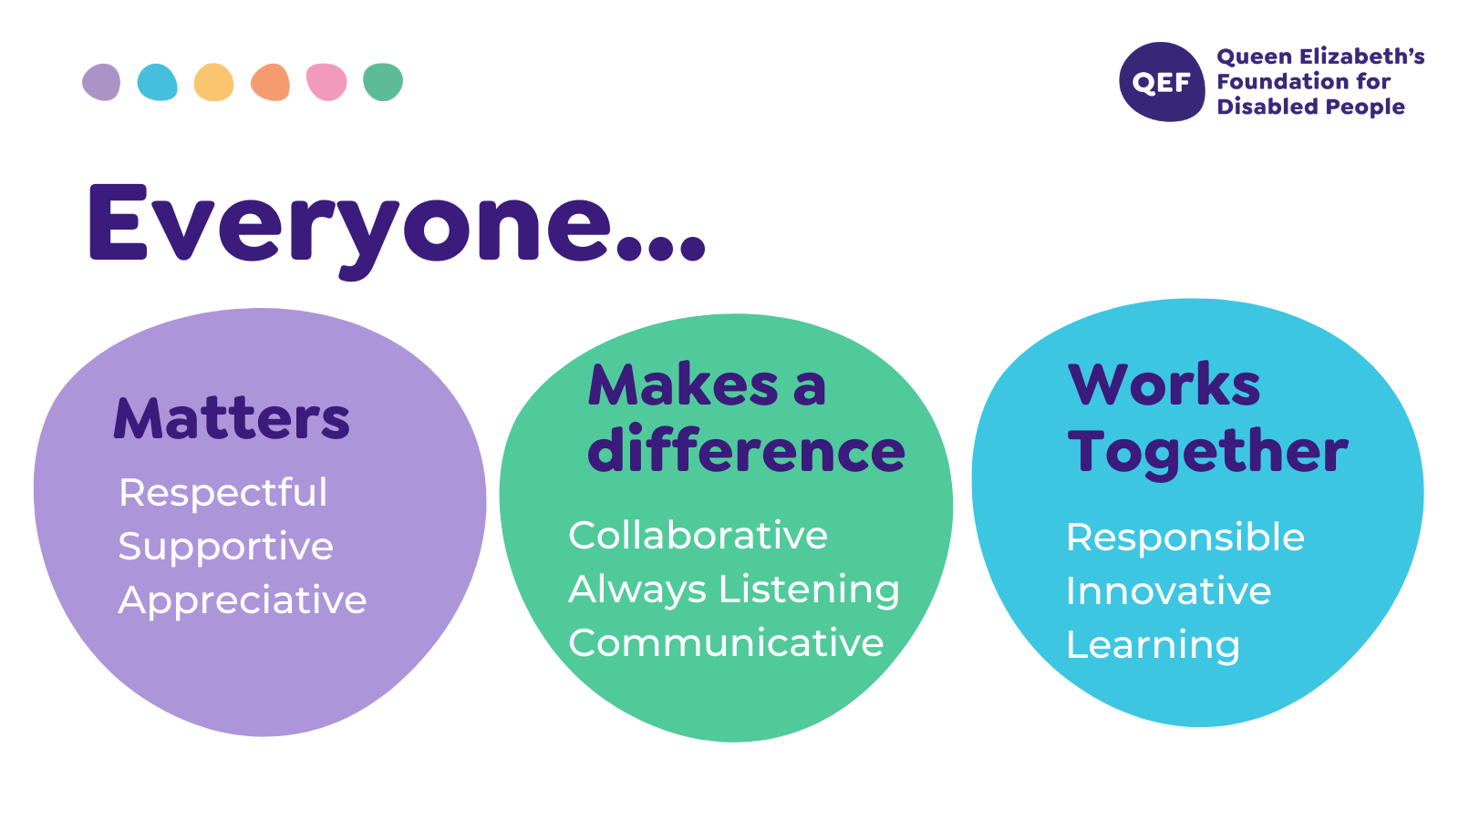
OTHER DUTIES

- You are expected to perform various tasks as necessitated by your changing role within QEF and the charity’s overall business objectives as reasonably requested by your designated manager or the CEO.
- You must read and ensure you understand the current versions of QEF’s policies and procedures and undertake to act in accordance with them at all times.
- You may be required to work at other locations in accordance with the responsibilities and duties of your role.
- The above is not an exhaustive list of duties and may be subject to change.

PERSON SPECIFICATION

Job title | Lead Physiotherapist band 7
Department | Therapies
QUALIFICATIONS AND TRAINING |  | ESSENTIAL | DESIREABLE
A professional qualification in physiotherapy |  | Y
A practising member of the Chartered Society of Physiotherapists |  | Y
Membership of Health Professions Council |  | Y
ACPIN membership |  |  | Y
Membership of any other Special Interest Group |  |  | Y
KNOWLEDGE AND SKILLS
A good standard of literacy and numeracy |  | Y
Excellent written and verbal communication skills |  | Y
Competent in Microsoft Word, Excel and Outlook |  | Y
Good demonstration of initiative, decision making and problem-solving skills |  | Y
Effective team working skills |  | Y
EXPERIENCE
Experience with complex neurologically impaired adults |  | Y
Managerial experience of leading a therapy team |  |  | Y
Relevant experience at Band 6 level |  | Y
Experience in all core areas of Physiotherapy |  | Y
Relevant experience in a hospital, outpatient or community setting |  | Y
Relevant post graduate training in neurological conditions/treatment |  | Y
PERSONAL ATTRIBUTES
Good personal time management |  | Y
Punctual |  | Y
Consistent |  | Y
Reliable |  | Y
Able to demonstrate commitment to QEF’s Values & Behaviours |  | Y
Team player |  | Y
Motivated |  | Y

