JOB DESCRIPTION

Job Title | Wheelchair, Seating & Posture Therapist
Hours | 15 hours per week (37.5 hours per week FTE)
Department | Mobility Services
Location | Carshalton
Level | Band 6 equivalent – not Agenda for Change
Reports to | Paediatric, Seating & Mobility Team Lead
Responsible for | Delivering assessments for powered and manual wheelchairs, scooters, Tryb4uFly, Bugzi, and car seating

QEF & ITS FAMILY OF CHARITIES

QEF is a Surrey-based charity committed to providing life-transforming services that enable people with disabilities to increase their independence and achieve their goals in life.

We work with over 10,000 disabled children and adults every year with physical or learning disabilities or acquired brain injuries. Whether it’s gaining new skills to live independently, rehabilitation after a brain injury or stroke, or improving independence through increased mobility; QEF helps disabled people to fulfil their potential in life.

QEF is structured into two main services - Mobility Services (who operate outreach services across the South of England), Care and Rehabilitation Centre located within our Leatherhead in Surrey campus. These are augmented by QEF Retail Trading (14 retail charity shops) and a family of smaller charities - MERU which provides innovative product solutions for Children and The Grange in Kent a residential care home for adults with a learning disability.

ROLE CONTEXT

Endorsed by the Department for Transport, QEF Mobility Services is one of the UK’s top 3 providers and, complete over 1,700 mobility assessments each year. We provide a variety of assessments to people of all ages so this role would suit someone that is looking for a varied post requiring a variety of skills and knowledge within a multi-disciplinary team. We are especially looking for an Occupational Therapist or a Physiotherapist with experience of working with wheelchair services, seating and posture.

Wheelchair and scooter assessments provide independent assessment through trial of a variety of equipment to identify the most suitable for individual’s needs.
Passenger assessments provide independent advice on suitable equipment to remove or minimise the risks of manual handling to ensure safe and comfortable transfer of individuals and their equipment into a vehicle. This includes travel by air and child car seats.

Tryb4uFly assessments identify seating solutions for air travel along with independent advice and information on preparation for travel.

JOB PURPOSE

- To provide wheeled mobility assessments (such as Wheelchair and Scooter assessments) for people of all ages with a broad range of disabilities.
- This is a unique opportunity to develop knowledge and skills to provide specialised assessments for Tryb4uFly, Bugzi and child car seats.
- To be a proactive member of our existing Clinical Team.
- To provide high-quality assessments using clinical knowledge and applying client centred principles.
- To work to ensure all client interaction is provided in compliance with QEF policies.
- To work as a team with other disciplines respecting their professional guidelines and opinions.

ROLE RESPONSIBILITIES

- To conduct a practical trial of product suitability for the client’s medical, physical and lifestyle needs, to recommend the most suitable manual, electric powered wheelchair or mobility scooter.
- To undertake equipment loading, seating and posture assessments, to advise clients of more suitable options and resolve manual handling concerns. A good understanding of posture management is required to assess seating requirements to improve pressure care and comfort. This may include car seat solutions, wheelchairs and scooters and travel by any medium including aeroplane, bus, taxi and train.
- Liaise with external agencies to assess for and arrange provision of appropriate equipment and adaptations to maximise independence.
- Provide assessments at Mobility Service and off-site venues.
- Provide ongoing clinical advice regarding children’s and adult mobility requirements to both internal and external stakeholders.
- Assist in the preparation and delivery of internal/external training courses for professionals and others and participate in the delivery of in-service training for staff.
- Providing supervision of students on clinical placement and less experienced staff.
- Maintain clinical records and write reports to a professional standard efficiently and effectively adhering to the RCOT guidelines for documentation and adhering to QEF and Driving Mobility documentation policy and standards.
- Responsible for ensuring that all mandatory training is up to date and to undertake appropriate CPD in line with role.
- Work with fundraising to develop case studies and cases for support.

BEING PART OF QEF MEANS

- Actively participating in learning, development and feedback opportunities and cycles as required by QEF’s policies and procedures.
- Acting in accordance with relevant legislative and regulatory requirements as may apply from time to time.
- Supporting and encouraging the involvement of volunteers.
- Promoting QEF’s Equal Opportunities policy and avoiding any behaviour that either directly or indirectly discriminates against others on the grounds of any protected characteristic.
- Taking Health and Safety duties seriously to ensure your safety and that of your colleagues and our residents and clients.
- Being an active team player and attending team meetings and briefings to which you are invited.
- QEF is committed to safeguarding and promoting the welfare of children and adults at risk and expects all staff and volunteers to share this commitment. All staff and volunteers must be responsible and accountable for their safeguarding practice and proactive in identifying and reporting safeguarding concerns.
- Being an ambassador of QEF’s Values and Behaviours in your approach to your role and to our staff, clients, and residents.

VALUES AND BEHAVIOURS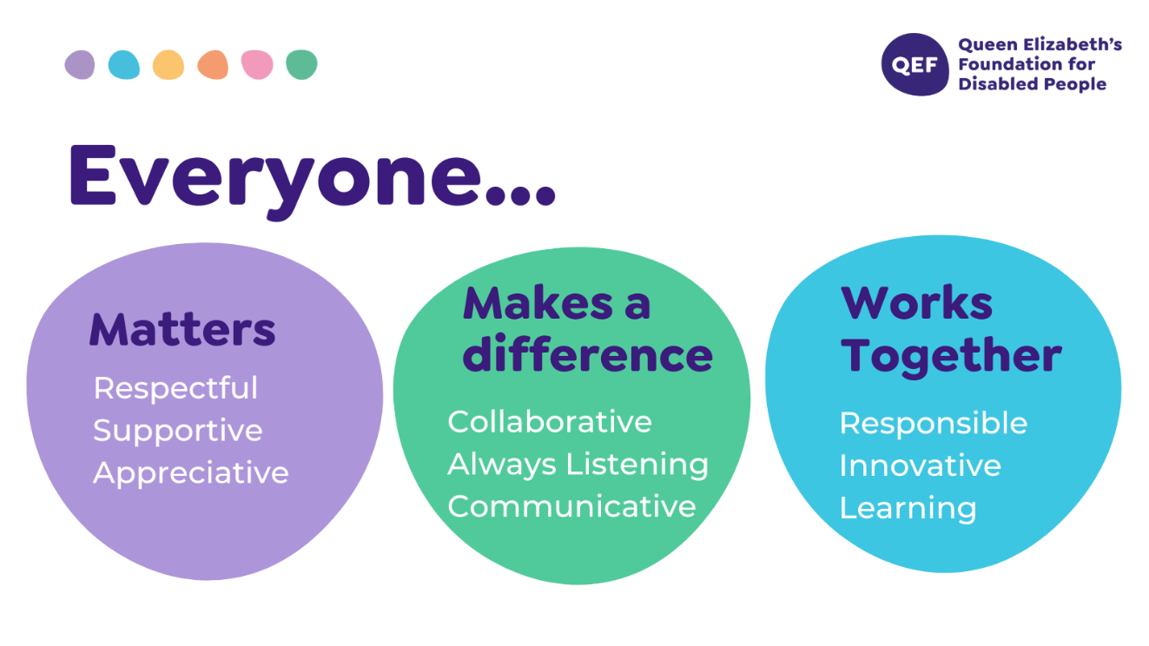

OTHER DUTIES

- You are expected to perform various tasks as necessitated by your changing role within QEF and the charity’s overall business objectives as reasonably requested by your designated manager or the CEO.
- You must read and ensure you understand the current versions of QEF’s policies and procedures and undertake to act in accordance with them at all times.
- You may be required to work at other locations in accordance with the responsibilities and duties of your role.
- The above is not an exhaustive list of duties and may be subject to change.

PERSON SPECIFICATION

Job title | Wheelchair, Seating & Posture Therapist
QUALIFICATIONS AND TRAINING |  | ESSENTIAL | DESIRABLE
Diploma or degree in Occupational Therapy or Physiotherapy |  | √
Registered with HCPC |  | √
Membership of relevant professional body e.g. BAOT/RCOT/CSP |  | √
Evidence of relevant post graduate courses/continual professional development |  | √
Driver with full driving license |  | √
Relevant postgraduate training in therapy with children |  |  | √
Masters module/qualification |  |  | √
KNOWLEDGE AND SKILLS
Can use own initiative to prioritise caseload and use clinical reasoning to make sound decisions and problem solve |  | √
Excellent written and verbal communication skills including use of Microsoft Word, PowerPoint, Excel and Outlook |  | √
Knowledge of clinical governance |  | √
Knowledge of infection control |  | √
Knowledge and skills using different models or frameworks |  | √
Have an empathetic approach with the ability to remain objective |  | √
Knowledge of neurological national clinical guidelines |  | √
Knowledge of the voluntary sector |  |  | √
Wide knowledge of the services which support adults and children with disabilities |  |  | √
EXPERIENCE
Post qualification experience of working with clients with physical disability and neurological rehabilitation with adults, children and their families |  | √
Experience in assessing for Mobility scooters, wheelchairs and buggies |  | √
Experience of assessing for and ordering/prescribing/fitting  equipment and adaptations |  | √
Experience in administering standardised assessments and clinical reasoning in choosing appropriate assessments |  | √
Experience with manual handing including complex handling procedures |  | √
Experience in composing risk assessments |  | √
Experience of working in a multidisciplinary team |  | √
Experience in applying standards and national guidelines to clinical practice |  |  | √
Experience in assessing for car seats, Equipment loading and stowing within a Vehicle |  |  | √
Experience in assessing for switching and communication aid mounting |  |  | √
Experience with the use of assistive equipment |  |  | √
Experience in Tryb4uFly assessments and Bugzi Assessments |  |  | √
PERSONAL ATTRIBUTES
Ability to demonstrate efficient, effective self-management including use of time, organisation, planning, problem solving, and managing stress of self and clients |  | √
Ability to use own initiative but ask for assistance when appropriate |  | √
Ability to work flexibly and proactively to meet the needs of a varied clinical caseload |  | √
Able to use self-reflection to improve clinical skills |  | √
To respond effectively to constructive feedback |  | √
Commitment to continuous professional development |  | √
To be empathetic and passionate in working with clients and families, with complex physical, cognitive and psychosocial needs |  | √
Ability to travel around the UK with occasional overnight stays. |  | √

