|  |  |
| --- | --- |
| **JOB DESCRIPTION** | |
| **Job Title** | Physiotherapist |
| **Hours** | 37.5 hours per week FTE |
| **Department** | Care and Rehabilitation Centre |
| **Location** | Leatherhead |
| **Level** | Band 6 |
| **Reports to** | Lead Physiotherapist |
| **Responsible for** | Physiotherapy assistants |

|  |
| --- |
| **QEF & ITS FAMILY OF CHARITIES** |

QEF is a Surrey-based charity committed to providing life-transforming services that enable people with disabilities to increase their independence and achieve their goals in life.

We work with over 10,000 disabled children and adults every year with physical or learning disabilities or acquired brain injuries. Whether it’s gaining new skills to live independently, rehabilitation after a brain injury or stroke, or improving independence through increased mobility and accessible holidays; QEF helps disabled people to fulfil their potential in life.

QEF is structured into two main services - Mobility Services (who operate outreach services across the South East of England), Care and Rehabilitation Center located within our Leatherhead Surrey campus. These are augmented by QEF Retail Trading (14 retail charity shops) and a family of smaller charities - MERU which provides innovative product solutions for Children, and The Grange in Kent, a residential care home for adults with a learning disability.

|  |
| --- |
| **ROLE CONTEXT** |

At QEF Care and Rehabilitation Centre (CRC) we offer neurorehabilitation and transitional support to clients after a stroke or other acquired brain injury. Our specialist multi-disciplinary team provides residential or outpatient therapies to those with physical, cognitive and/or communication disabilities, which may also include mild to moderate behavioural problems.

We have a diverse range of one-to-one support programs, tailored to help improve social and functional abilities as well as support for that important move home and back to education or work.

|  |
| --- |
| **JOB PURPOSE** |

* To be responsible for the assessment and treatment of clients with acquired brain injury, stroke and incomplete spinal injury under the direction of the senior physiotherapists. At times throughout the year, you will also support a small number of clients requiring general in-patient rehabilitation to support our local NHS Trusts.
* To liaise with other members of the multidisciplinary team to ensure continuity and consistency regarding clients’ physical management.

|  |
| --- |
| **ROLE RESPONSIBILITIES** |

* To hold responsibility for own caseload and be responsible for a defined area of the service, working without direct supervision.
* To work as a member of the multi-disciplinary neuro-rehabilitation team, contributing to the planning, development and delivery of an effective and efficient service.
* Providing assessment and developing treatment programmes for clients.
* Ongoing evaluation of treatment regimes in conjunction with the senior therapists.
* Setting of clients’ short- and long-term goals.
* Assisting in casting and splinting as appropriate.
* Integrating and monitoring treatment programmes in the clients’ environment whether carried out by therapy support worker or care staff.
* Integrating strategies agreed on by the multi-disciplinary team into treatment management.
* Participating in the assessment of wheelchair seating requirements for clients in conjunction with the Occupational Therapy department.
* To support home visits as required in conjunction with the Occupational Therapy department.
* Keeping abreast of developments within the profession.
* Supervising the therapy support workers as required in conjunction with the senior physiotherapists.
* Instructing members of the care and support team regarding moving and handling, transfers, splints, standing and walking, in conjunction with the senior therapists.
* Advising and assisting other session staff on the correct working environment to enable clients to maximise their physical abilities, in conjunction with the senior therapists.
* Contributing to clients’ reports for reviews and case conferences.
* Ensuring that all equipment used is in good order and always ensuring the safety of clients and staff in accordance with the Health & Safety at Work Act.
* Participate in the key therapist/worker program for clients – providing information to and liaising with clients, families, carers and other involved agencies to facilitate their rehabilitation and ensure safe discharge.
* Maintaining client records and providing written assessments, referrals and reports as required.

|  |
| --- |
| **BEING PART OF QEF MEANS** |

* Actively participating in learning, development and feedback opportunities and cycles as required by QEF’s policies and procedures.
* Acting in accordance with relevant legislative and regulatory requirements as may apply from time to time.
* Supporting and encouraging the involvement of volunteers.
* Promoting QEF’s Equal Opportunities policy
* Taking Health and Safety duties seriously to ensure your safety and that of your colleagues and our clients.
* Being an active team player and attending team meetings and briefings to which you are invited.
* QEF is committed to safeguarding and promoting the welfare of children and adults at risk and expects all staff and volunteers to share this commitment. All staff and volunteers must be responsible and accountable for their safeguarding practice and proactive in identifying and reporting safeguarding concerns.
* Being an ambassador of QEF’s Values and Behaviours in your approach to your role and to our staff and clients.

|  |
| --- |
| **VALUES AND BEHAVIOURS** |

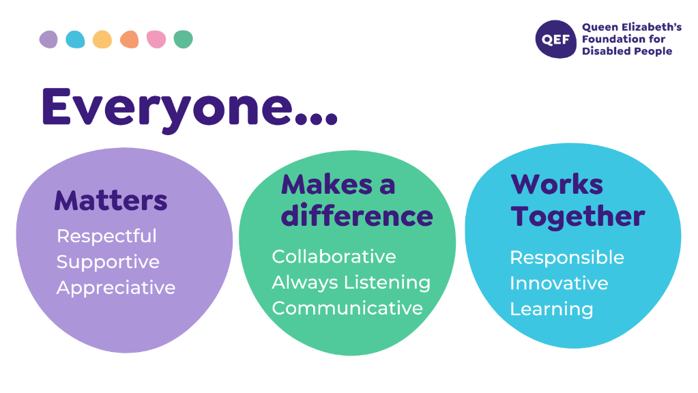

|  |
| --- |
| **OTHER DUTIES** |

* You are expected to perform various tasks as necessitated by your changing role within QEF and the charity’s overall business objectives as reasonably requested by your manager or the CEO.
* You must read and ensure you understand the current versions of QEF’s policies and procedures and undertake to act in accordance with them at all times.
* You may be required to work at other locations in accordance with the responsibilities and duties of your role.
* The above is not an exhaustive list of duties and may be subject to change.

|  |  |  |  |
| --- | --- | --- | --- |
| **PERSON SPECIFICATION** | | | |
| **Job title** | Physiotherapist Band 6 | | |
| **Service** | Care and Rehabilitation Centre, Leatherhead | | |
|  | | | |
| **QUALIFICATIONS AND TRAINING** | | **ESSENTIAL** | **DESIREABLE** |
| A professional qualification in physiotherapy | | Y |  |
| A practising member of the Chartered Society of Physiotherapists | | Y |  |
| Membership of Health Professions Council | | Y |  |
| ACPIN membership | |  | Y |
|  | |  |  |
| **KNOWLEDGE AND SKILLS** | |  |  |
| A good standard of literacy and numeracy | | Y |  |
| Excellent written and verbal communication skills | | Y |  |
| Competent in Microsoft Word and Outlook | | Y |  |
| Good decision making and problem-solving skills | | Y |  |
| Can use initiative | | Y |  |
|  | |  |  |
| **EXPERIENCE** | |  |  |
| Experience of neurorehabilitation to a specialist level | |  | Y |
| Experience of working in a multi-disciplinary team | | Y |  |
| Confident in administering specialist neurological assessments | |  | Y |
| Evidence of post graduate CPD | |  | Y |
| Proven ability to work with, and supervise, assistants | |  | Y |
|  | |  |  |
| **PERSONAL ATTRIBUTES** | |  |  |
| Ability to demonstrate empathy, sensitivity and tact to a diverse client group | | Y |  |
| Highly motivated with a strong client focussed approach | | Y |  |
| Flexible | | Y |  |
| Proactive approach to service delivery | | Y |  |
| Team player | | Y |  |
| Able to demonstrate commitment to QEF’s Values & Behaviours | | Y |  |
| Excellent inter-personal skills, including observation and listening | | Y |  |