JOB DESCRIPTION & PERSON SPECIFICATION

JOB DESCRIPTION

Job Title : Team Supervisor -Days and Night

Hours | 37.5 hours per week FTE
Department | Care
Location | Care and Rehabilitation Centre
Level
Reports to | Head of Care
Responsible for | Care and Rehabilitation support workers

QEF & ITS FAMILY OF CHARITIES

QEF is a Surrey based charity committed to providing life-transforming services that enable people with disabilities to increase their independence and achieve their goals in life.

We work with over 10,000 disabled children and adults every year with physical or learning disabilities or acquired brain injuries. Whether it’s gaining new skills to live independently, rehabilitation after a brain injury or stroke, or improving independence through increased mobility and accessible holidays; QEF helps disabled people to fulfil their potential in life.

QEF is structured into two main services - Mobility Services who operate outreach services across the South East of England), Care and Rehabilitation Center located within our Leatherhead in Surrey campus. These are augmented by QEF Retail Trading (14 retail charity shops) and a family of smaller charities - MERU which provides innovative product solutions for Children and The Grange in Kent a residential care home for adults with a learning disability.

ROLE CONTEXT

At QEF Care and Rehabilitation Centre (CRC) we offer neurorehabilitation and transitional support to clients after a stroke or other acquired brain injury. Our specialist multi-disciplinary team provides residential or outpatient therapies to those with physical, cognitive and/or communication disabilities, which may also include mild to moderate behavioral problems.
We have a diverse range of one-to-one support programs, tailored to help improve social and functional abilities as well as support for that important move home and back to education or work.

JOB PURPOSE

The Team Supervisor at QEF Care and Rehabilitation Centre plays a key role in delivering top-tier, person-centred neurorehabilitation, and care for clients with a range of conditions. As a Team Supervisor, you will provide care to clients in accordance with their assessed needs and will lead the care team to provide high-quality, personalized care to clients. Your focus will be on maintaining excellent standards, managing your team effectively, and adhering to all relevant healthcare regulations.

ROLE RESPONSIBILITIES

Supervision:
- Lead, plan, and support staff in their duties, ensuring smooth operation of shifts.
- Foster collaborative working and effective communication within the team.
- Deputize in the absence of the Assistant Managers or the Care Lead, assuming lead supervisor status as needed.
- Provide effective supervision and appraisal to support workers, setting objectives, identifying training needs, monitoring performance, and giving feedback.
- Address staff conduct issues and conduct investigations in line with policies.
- Assist in staff induction and provide training on specialist topics.
- Maintain and further personal training and development.
- Ensure the team meets all mandatory and refresher training requirements and encourage their personal development.

Service Delivery:
- Create a caring, safe, responsive, and welcoming environment, upholding the rights and welfare of service users.
- Undertake personal care and daily living skills tasks in line with individual needs, maintaining dignity always.
- Follow and update individual personal support plans, including needs, risk management, and goals.
- Order, receive, store, and administer medication, managing a safe and effective medication control system, subject to training and competencies.
- Facilitate and participate in recreational, educational, and social activities for residents.
- Support residents in establishing effective communication with all relevant parties.
- Maintain accurate, timely records and reports, ensuring confidentiality.
- Respond promptly and appropriately to concerns.

Quality:
- Address initial complaints, concerns, and feedback from residents, families, and other stakeholders.
- Participate in staff meetings and service reviews, contributing to continuous evaluation and improvement.
- Carry out and comply with all health and safety and quality audit outcomes to uphold high standards of care and support.
General:
- Assist in handling enquiries.
- Maintain effective and appropriate communication within the service, organization, and to external audiences using various media.
- Undertake a champion role as identified by the care leads.
- Must be a driver with the ability to drive manual cars and willing to undertake MIDAS training

BEING PART OF QEF MEANS

- Actively participating in learning, development and feedback opportunities and cycles as required by QEF’s policies and procedures.
- Acting in accordance with relevant legislative and regulatory requirements as may apply from time to time.
- Supporting and encouraging the involvement of volunteers.
- Promoting QEF’s Equal Opportunities policy and avoiding any behaviour that either directly or indirectly discriminates against others on the grounds of any protected characteristic.
- Taking Health and Safety duties seriously to ensure your safety and that of your colleagues and our residents and clients.
- Being an active team player and attending team meetings and briefings to which you are invited.
- QEF is committed to safeguarding and promoting the welfare of children and adults at risk and expects all staff and volunteers to share this commitment. All staff and volunteers must be responsible and accountable for their safeguarding practice and proactive in identifying and reporting safeguarding concerns.
- Being an ambassador of QEF’s Values and Behaviours in your approach to your role and to our staff, clients, and residents.

VALUES AND BEHAVIOURS
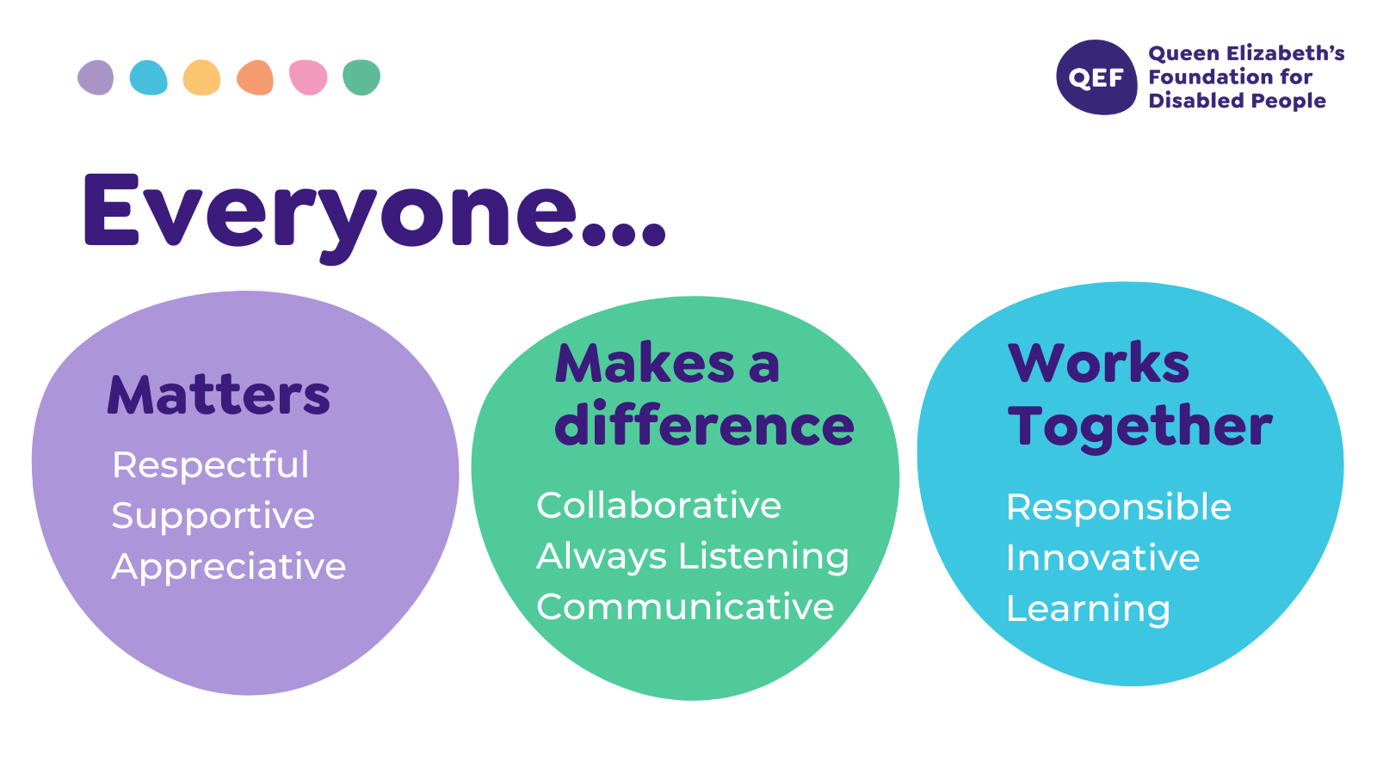
OTHER DUTIES

- You are expected to perform various tasks as necessitated by your changing role within QEF and the charity’s overall business objectives as reasonably requested by your designated manager or the CEO.
- You must read and ensure you understand the current versions of QEF’s policies and procedures and undertake to act in accordance with them at all times.
- You may be required to work at other locations in accordance with the responsibilities and duties of your role.
- The above is not an exhaustive list of duties and may be subject to change.

PERSON SPECIFICATION

Job title: | Team Supervisor
Service | Care and Rehabilitation Centre
QUALIFICATIONS AND TRAINING |  | ESSENTIAL | DESIREABLE
NVQ/QCF Level 3 in Health and Social Care or equivalent or working towards Lead Adult Care Apprenticeship  Minimum of 1 years’ experience of working with people with physical and/or learning disabilities  Demonstrable levels of numeracy & literacy equivalent to GCSE (A-C) or NVQ Level 2 (or by test). |  | Essential  Essential  Essential
Experience of supervising staff |  | Essential
Full UK driving licence preferably with the ability to drive manual cars |  | Essential
Willing to undertake MIDAS training to obtain QEF certification |  | Essential
Training Qualification |  |  | Desirable
KNOWLEDGE AND SKILLS
Knowledge and understanding of the needs of adults with a disability |  | Essential
Knowledge of regulatory standards |  | Essential
Knowledge and understanding of person-centred planning |  | Essential
Understanding of the principles of Safeguarding |  | Essential
Ability to communicate effectively with a range of people using a variety of methods |  | Essential
Ability to plan own work and allocate tasks as required |  | Essential
Ability to promote equal opportunities in accordance with QEF policy |  | Essential
Ability to build appropriate relationships with residents, families and relevant others |  | Essential
Ability to contribute to changes that improves service delivery |  |  | Desirable
Knowledge and understanding of the needs of adults with a disability |  | Essential
Knowledge of regulatory standards |  | Essential
EXPERIENCE
Experience of writing person centred support plans and risk assessments |  | Essential
Experience of using Microsoft Office applications including Word, Excel and Outlook |  | Essential
Experience of using an electronic rota system |  |  | Desirable
Experience of managing conflict |  |  | Desirable
Experience of supervising individuals and a team, setting objectives and motivating staff |  | Essential
PERSONAL ATTRIBUTES
Ability to work flexible and unsociable hours |  | Essential
Ability to remain calm under pressure |  | Essential
Ability to use initiative and generate workable solutions |  | Essential
Prepared to develop own skills and knowledge |  | Essential
Ability to maintain effective working relationships |  | Essential
Promotes the organisation positively and works with the values |  | Essential
Ability to work flexible and unsociable hours |  | Essential

